

Bank of China New York Branch Model Documentation

Liquidity Stress Testing Documentation V 5.1

Treasury

Aug 2021

Version | Date Change Made | Drafter | Reviewer | Approver | Description of Changes
V1.0 | 05/31/2016 | Xiang Fang | Niraj Biswas | Min Li | Creation
V2.0 | 11/29/2017 | Yuanyuan Ma/Xiang Fang | Kexiang Xiang | Min Li | Annual Review Update
V2.1 | 5/1/2018 | Xiang Fang | Kexiang Xiang | Min Li | Loan Commitment Ratio Update
V2.2 | 12/1/2018 | Xiang Fang | Kexiang Xiang | Min Li | Annual Review Update Ratio Update
V3.0 | 03/06/2019 | Xiang Fang | Kexiang Xiang | Xiaowei Zhang | Transferred to TRY
V4.0 | 11/25/2019 | Shiyao Lu/Xiangjun Chen | Hongsheng Guo | Xiaowei Zhang | Revisit and update
V4.1 | 03/25/2020 | Xiangjun Chen | Hongsheng Guo | Xiaowei Zhang | Revisit and update
V4.2 | 09/28/2020 | Xiangjun Chen | Hongsheng Guo | Xiaowei Zhang | Assumption update
V5.0 | 05/07/2021 | Xiangjun Chen/Chulin Yan | Hongsheng Guo | Qian Peng | Revisit and update
V5.1 | 08/23/2021 | Xiangjun Chen/Chulin Yan | Hongsheng Guo | Qian Peng | Revisit and update

Identifying Information
Title | EPS Liquidity Stress Testing Documentation
Procedure Owner | TRY
Contact Information | Hongsheng Guo, SVP
Effective Date | 08/23/2021
Location | J:\1. Policy, Procedure & Plan\2. TRY Procedures
Document Type | Methodology Documentation

Reviewed by
Hongsheng Guo  SVP |  |  | 8/23/2021
Hongsheng Guo  SVP | Signature |  | Date

Approved by
Qian Peng
SVP & Head of Treasury
Qian Peng  SVP & Head of Treasury | Signature |  | Date

Contents
1. Executive Summary 1
1.1 Model Tiering 1
2. Business Background 2
2.1 Business Profile and Model Use 2
2.2 Overview of BOC Combined U.S. Operations 2
3. Modeling Data 4
3.1 Development Data 4
3.2 Model Input 5
3.3 Data Governance 6
4. Model Methodology and Development 8
4.1 Stress Scenarios 8
4.2 Stress Assumptions 11
4.3 Cash Flow Projection on 14-Day Horizon 58
4.4 Excess Liquidity Buffer Ratio 64
4.5 Future Enhancement 64
5. Model Output Analysis 66
5.1 Ad hoc Analysis 66
5.2 Sensitivity Analysis 66
5.3 Diagnostic Analysis 66
5.4 Back Testing 66
6. Model Implementation 68
6.1 Implementation Process 68
6.2 Model Components 69
6.3 Implementation testing 70
7. Model Operational Control 71
7.1 Overall operation control 71
7.2 Model Use Procedures 71
8. Model Governance and Monitoring 78
8.1 Roles and Responsibilities 78
8.2 Ongoing Monitoring 79
9. Appendices 80
9.1 Glossary 80
9.2 Additional Analysis 80
9.3 Cash Flow Projection Research & Study References 81
9.4 CUSO Risk and Finance Officers 83
Reference 84

Executive Summary
This document serves as a point of reference for Bank of China (“BOC”) to estimate the impact of stress events on the liquidity position of BOC U.S. Branches and combined U.S. operations (“BOC CUSO”). In conjunction with BOC’s U.S. Governing Policies, i.e. Contingency Funding Plan (“CFP”) [1] and Liquidity Risk Management Framework, this working document will enable management to monitor potential liquidity events as they unfold and react to a potential liquidity crisis.
BOC will periodically assess its liquidity stress testing process relative to industry best practices and regulatory guidance and requirements. Any material enhancements will be reflected in this document accordingly.
Specifically, this document describes the various types of liquidity stress scenarios (idiosyncratic, systemic, and combined) to be performed, the assumptions made under each scenario and the procedures to run this model. Conforming to the BOCNY Model Risk Management Procedure, this document is broken down into the following sections.
Section 2: Business Background describes the general business background and what the model intended to measure.
Section 3: Model Input describes the model’s data need.
Section 4: Model Methodology and Development provides information of model input, methodologies and output and its limitations.
Section 5: Model Output Analysis lists the different testing used to assess the accuracy of the model.
Section 6: Model implementation describes the implementation process.
Section 7: Model Operational Control outlines the version control and reference to the model user manual.
Section 8: Model Governance and Monitoring describes role and responsivities and the overall monitoring process.

Model Tiering
Though the EPS Liquidity Stress Testing is not required for BOC NY after the Federal Reserve Bank’s tailoring rule (12 CFR § 252.145)[2], to maintain the sound risk management practice, BOCNY will continue to maintain current liquidity stress testing framework and modelling for internal risk management purpose. As a result, the BOCNY LST model has been downgraded to tier 2 as of February 21st, 2020 per confirmation by ERM.

Business Background

Business Profile and Model Use
The objective of BOC’s U.S. liquidity stress testing process is to identify and prepare for stressed liquidity situations that protect depositors, creditors, and investors of BOC. By referring to EPS requirements (§ 252.157. (c). (3)) [2], though not required since Jan 1st, 2020, the Bank would maintain sufficient liquidity buffer to meet the projected net stressed cash-flow need over the first 14 days of a stress test with a 30-day planning horizon. By utilizing these stress test results, BOC can create an adequate liquidity buffer composed of high liquid assets (“HLAs”). This document outlines the assumed stress test scenarios, inflow, and outflow rates on assets, liabilities and off-balance sheet items. It assesses the availability of potential countermeasures to be relied upon in the event of a stress scenario.
TRY identifies, quantifies and monitors Liquidity Risk. Specifically, the bank assigns TRY the responsibilities in routinely calculating and monitoring Liquidity Stress Test results and timely reporting the results to senior management and department heads, Market & Liquidity Risk Committee, and Asset Liability Committee (ALCO). The results have an enterprise level impact on liquidity risk management, balance sheet management, investment, and business strategy etc.

Overview of BOC Combined U.S. Operations
BOC CUSO includes both banking and non-banking activities. Figure 1 depicts the organizational structure of BOC CUSO. BOC U.S. Branches conduct BOC’s banking operations in the U.S. through four federally licensed branches: the New York Branch (“BOCNY”), the Queens Branch, Bank of China Chicago Branch, the Bank of China Los Angeles Branch. For management and financial reporting purposes, the U.S. branches are consolidated and controlled by BOCNY.
BOC U.S. Branches specialize in corporate lending, international trade services, treasury services, USD clearing, and retail banking. Clients are comprised of mainly Chinese companies operating in the U.S., U.S. Fortune 500 companies, and high net-worth individuals. BOC U.S. Branches also offers services to external financial institutions and BOC internal branches and affiliates, including taking deposits and making overnight or term loans to different counterparties with sufficient credit. The back offices of BOC U.S. Branches, including the Clearing Department, Treasury, and Loan Administration, provide services to internal stakeholders. Furthermore, BOCNY acts as a back office hub supporting BOC U.S. Branches funding needs.
In addition to the U.S. Branches, BOC CUSO includes three non-bank/non-branch operating entities domiciled in the U.S. The three entities are: BOC Aviation (USA) Corporation(“BOCA”), an aircraft leasing entity; BOC International (USA) (“BOCI”) Holdings, which separate into BOCI (USA) Inc.(“BOCI USA”), an investment brokerage business, and BOCI Commodities & Futures (USA) LLC (“BOCI CFUS”), a commodities and futures broker; and last entity being , 7 Bryant Park Owner LLC (“7BP”), a commercial real estate property purchased by the Bank in 2015. For additional information on all BOC CUSO entities please refer to 4.2.6 Other U.S. Entities.
Figure 1: Bank of China Combined U.S. Operations Organizational Structure

Modeling Data

Development Data
Data of both BOC U.S. Branches and combined U.S. operations is collected:
BOC U.S. Branches
Data to build and perform the model is extracted in individual TB lines from T24 and OPICS with different contractual maturities, additional analysis for key customers is also introduced recognizing that certain customers could be of greater liquidity risk due to their balance. Reconciliation on the collected data is required to ensure a balanced balance sheet and the consistency among different data sources.
Other U.S. Entities
BOC CUSO’s other U.S. entities provide the required data for the stress tests. Based on the methodology document, most of non-branch entities have no liquidity impact under market stress, except 150mm USD credit line that BOC NY offer to BOCI C&F. Other U.S. Entities would notify BOC NY for any change of related issues.
Below table shows the data sources of all assets, liabilities and off balance sheet items collected in the Liquidity Stress Testing model.
Table 1: BOC U.S. Branches Input Data Description
Product | Description | Data Source
On Balance Sheet Items
Assets
FRB Balance | Both reserve balance and other balance | T24
Due from Banks | Demand and time deposits in Inter-banks, affiliates and third-party FIs | T24 and OPICS
Securities | Unpledged HQLA Securities, haircuts and non-buffer securities | T24, OPICS and TRY Liquidity & Funding Desk
Loans | Syndication loans, time loans and trade financing loans | T24
BOLI | Bank Owned Life Insurance | T24
Other Assets |  | T24
REPO Assets |  | OPICS
Liabilities
Due to Banks | Demand deposits and call loans from Inter-banks, affiliates and third-party FIs. | T24 and OPICS
Demand, MM & Savings | Non-maturity deposits from retail and corporates | T24
Time Deposits | Time deposits from retail and corporates | T24
FDIC Sweep Deposits | ICS, CEDARS, IND, MMDA and others if any | T24
Brokered CDs & Yankee CDs |  | OPICS
Bond Issuance |  | T24
Other Liabilities |  | T24
REPO Liabilities |  | OPICS
Equity |  | T24
Off Balance Sheet Items
Loan Commitments | Liquidity and credit loan commitments | T24
Credit Enhancement Facility | CPDP and 80/20 | T24
Standby Letter of Credit |  | T24

Besides the historical data extracted from above sources, peer bank data during previous stress periods [8] that applicable to support analysis used for the liquidity stress test scenarios is also utilized to develop the liquidity stress test assumptions. Please refer to section 4.2.3 Source of Assumptions for details.

Model Input
The individual TB lines sourced from T24 and OPICS are summarized into the certain format to make a transition to the stress test model. The balance of each line item shall be equal to the original balance sheet data (Trial Balance Report) from T24. If any line item does not add up to the original Trial Balance Report number, further investigation needs to be done in order to make sure data accuracy. The differences between the balance sheet in use and the original balance sheet can be the new products that are not originally captured in the stress test settings. In that situation, TRY will work with the relevant business line and MRD, the second line of defense to develop the assumption for any new product or revise the assumptions for existing line items.
- Data Base T24
- Data Base OPICS
- Summary by TB & Maturity
- Liquidity Stress Test Interface
- Liquidity Stress Test Model
Figure 2: Data Flow Process

Data Governance
Data Controls
Five types of controls have been put in place for the stress test model. They are detailed in the table below.
Table 2: Controls of Stress Test Model
Controls | Descriptions
Spreadsheet Reconciliation | Spreadsheet controls ensure assets equal liabilities + equity and cash flow are reconcilable to changes in balances;  Spreadsheet controls ensure there are no discrepancies between line item subtotals and underlying components.
Spreadsheet Protection | The assumptions for the stress test model are locked by password. Only authorized person have access to change the password;  Non user-input cells are locked.
Variance Analysis | Each month after conducting the stress test, TRY:  Compares and reconciles the change in the liquidity buffer requirement from the prior month, utilizing a variance analysis tab contained in the tool;  Compares opening spot balances with the prior month to identify any large variances for further investigation.
GL/TB Line reconciliation | TB lines are totaled and compared to GL totals to ensure any new line items are captured.
Management Control | Model output is reviewed by the designated employee from TRY

Data Integrity
To ensure the accuracy of the data, the followings are executed:
- Ensure that the data profile is in balance;
- Identify new TB_line or product that might not have been setup into the model template;
- Recalibrate run-off rates periodically with the latest data.

Model Methodology and Development

Stress Scenarios
After evaluating its systemic and idiosyncratic liquidity risks, BOC selected the following three scenarios: idiosyncratic crisis, systemic crisis, and combined crisis scenario. For each scenario, cash flow assumptions on different time horizons are made to satisfy comprehensive cash flow projection needs. The descriptions and impacts of the three scenarios are addressed in detail in 4.1.1, 4.1.2, and 4.1.3.
BOC continuously assesses its liquidity risks and will modify these hypothetical scenarios when appropriate. BOC may also conduct ad hoc liquidity stress scenario analysis if deemed necessary.

Idiosyncratic Stress Scenario
The idiosyncratic stress on BOC will be precipitated by unease over the immediate viability of its businesses; these anxieties may include but are not confined to, solvency concerns related to fraud, trading losses, a large client default, or a link to a public scandal. Regardless of the cause for concern, this analysis assumes an idiosyncratic event in which BOC’s long-term debt rating is downgraded three notches while other banks retain their current ratings. Consequently, the market perception of BOC’s ability to meet its liabilities falters, and counterparties reevaluate the risk of placing or maintaining funds with BOC given the perceived potential for insolvency.
As of Dec 2020, BOC’s long-term debt was rated A1, A, and A by Moody’s, Standard & Poor’s and Fitch, respectively. This scenario defines the liquidity risk associated with a three-notch long-term credit rating downgrade. It is assumed the new ratings for BOC’s long-term debt will be Baa1, BBB, and BBB respectively. As shown in Table 1, BOC’s credit rating has remained within the current range for at least eleven years. Therefore, BOC has concluded that a three-notch downgrade will not result in a less than investment-grade credit profile for the bank.
Table 3: BOC Credit Rating History 2007 – 2020 [7]
Year | Standard & Poor’s | Moody’s | Fitch
2007 | A- | A1 | A
2008 | No Credit Rating Change
2009 | No Credit Rating Change
2010 |  | No Credit Rating Change
2011 | A | No Credit Rating Change
2012 | No Credit Rating Change
2013 | No Credit Rating Change
2014 | No Credit Rating Change
2015 | No Credit Rating Change
2016 | No Credit Rating Change
2017 | No Credit Rating Change
2018 | No Credit Rating Change
2019 | No Credit Rating Change
2020 | No Credit Rating Change
During the first 30 days of idiosyncratic stress, BOC U.S. Branches experience significant deposit run-off from credit-sensitive depositors. Wholesale funding is not available while the bank is under name crisis stress. Retail depositors remain relatively stable with many covered by FDIC deposit insurance. BOC U.S. Branches are assumed to continue to roll over existing client loans to preserve the reputation of a going concern. There will be little or no support from head office (“BOC H.O.”) during the early crisis period.
Following the first 30 days, it is expected the BOC H.O. position strengthens, with appropriate government intervention, and is able to provide financial support to BOC U.S. branches.
Figure 3 below provides an overview of the impacts to BOC CUSO from the idiosyncratic crisis.
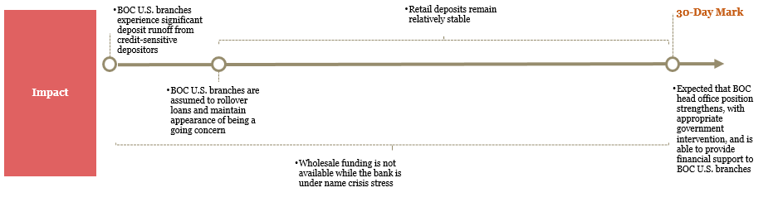
Figure 3: Impact of Idiosyncratic Stress Scenario

Systemic Stress Scenario
The systemic scenario assumes events similar to the 2008 banking crisis, with impacts contained within the U.S. and do not significantly impact BOC operations outside of the U.S. The investor community has lost confidence and there is no demand for debt issued by financial institutions, causing a collapse in market liquidity. The appetite for normally liquid securities falls sharply and only the most highly rated, market-supported securities can be sold or funded without higher than normal haircuts. Conversely, most asset-based funding will experience significantly increased haircuts. Unsecured funding markets are non-existent for a period of six months. Moreover, the associated credit crisis would result in the shrinking of interbank money market funds and an increase in drawdowns on committed lines. Depositors reposition a significant portion of liquidity – particularly excess funds – to high-quality securities such as treasury bills or government money market mutual funds.
Commonly adopted remediation actions in these scenarios include various types of large-scale government intervention, such as bank closures, nationalizations, mergers, the creation of a bank restructuring agency and/or an asset-management company, and recapitalization. Sometimes these actions are accompanied by forbearance that allows the suspension or reduction of loan payments under certain circumstances and for specified lengths of time. Intermittent changes in loan classification and loan-loss provisioning are also allowed.
During the first 30 days of the systemic stress, BOC U.S. Branches experience mild deposit run-off from credit-stressed depositors. Retail depositors remain relatively stable with many covered by FDIC deposit insurance. Beyond the first 30 days, BOC U.S. Branches continue to experience run-off from excess deposits while retaining operational funds. BOC U.S. branches are assumed to roll over loans under tighter credit quality conditions. BOC H.O. will monitor events in the U.S. closely and support for the U.S. branches is expected to continue.
Figure 4 provides an overview of the impacts to BOC CUSO from the systemic crisis.
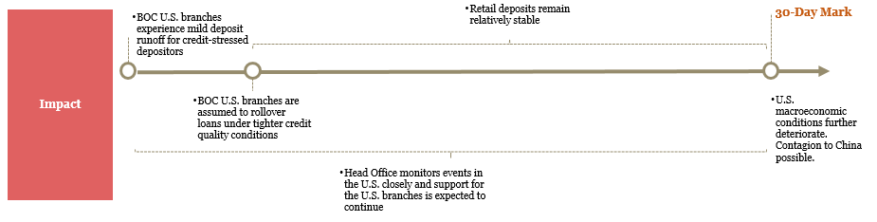
Figure 4: Impact of Systemic Stress Scenario

Combined Stress Scenario
In the combined crisis scenario, there is a sharp slowdown in the Chinese economy. GDP growth rate has dropped significantly and has influenced global trade. There are significant knock-on effects on developed economies and global corporations. China implements strict currency controls, limiting cash flow out of China to the United States. This precipitates a systemic, global economic downturn.
The global downturn impairs the credit profile of many companies. Commodity-focused industries such as oil and gas, coal, steel, and mining are particularly impacted. BOC is one of the largest banks in China and is focused on providing international services more than the other state-owned peers provide. Specifically, BOC U.S. Branches have significant exposure to the oil and gas industry, shipping, and steel companies with exposures to clients such as China Shipping Development, BX Steel, Tiptop, and Sinopec. As such, they are disproportionately impacted with larger loan losses relative to other global financial institutions leading to an idiosyncratic name crisis.
During the first 30 days of the combined idiosyncratic and systemic stress, BOC H.O. repatriates excess funds from their overseas branches and fails to provide liquidity support to their foreign branches as they shore up a home office. BOC U.S. branches experience significant deposit run-off from credit-sensitive depositors. Wholesale funding is not available while the bank is under severe stress. Retail depositors remain relatively stable with many covered by FDIC deposit insurance. BOC U.S. branches roll over existing loans with BOC internal network and select corporate counterparties to help maintain important relationships. Loan repayments coming directly from China may experience impediment because of currency controls.
Following the first 30 days, macroeconomic conditions continue to deteriorate but at a more moderate rate. It is expected the BOC H.O. position strengthens after 30 days, with appropriate government intervention, and is able to provide financial support to BOC U.S. branches. Currency control restrictions are relaxed.
Figure 5 summarizes the impacts of the combined crisis.
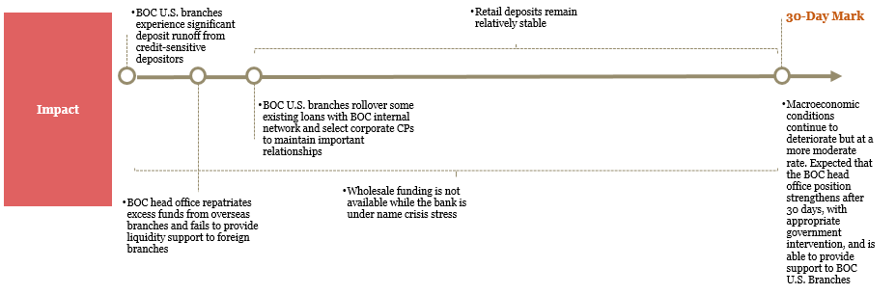
Figure 5: Impact of Combined Stress Scenario

Stress Assumptions

Assumptions Development Approach
Liquidity stress test assumptions were developed based on BOC CUSO’s empirical data, industry research, expert judgment, and regulatory guidance. There are four steps in developing the assumptions, detailed in Table 3.
Table 4: Assumptions Development Approach
Four steps to developing the assumptions
Step 1 | Analyze the BOC CUSO balance sheet, off-balance sheet accounts, and potential countermeasures. BOC conducted detailed analyses for on and off-balance sheet items, taking into consideration the characteristics of each product, counterparty profile, and any complexity or potential risks. The behavioral profile of each product also entailed empirical data analysis, industry comparison, as well as regulatory guidance. Empirical data included GL account data extending back to January 1, 2008. Industry data included analysis of run-off experienced by U.S. banks during the 2007-2008 crisis; examination of specific cases of failed banks (e.g., Wachovia); and publicly available industry studies (e.g., The Clearing House study). Refer to Appendix B Sources of Assumption Data for additional detail.
Step 2 | Identify special clients and products. For particular products and clients, such as large concentrated deposits, and special pricing clients, additional client-level data analysis was performed.
Step 3 | Meet with lines of business (LOB) to discuss and validate initial assumptions. For those special clients and products identified in step 2, the LOBs were interviewed to ensure a clear understanding of the client’s and products’characteristics.
Step 4 | Tailor assumptions to each scenario. For the idiosyncratic scenario and systemic scenario, we considered assumptions from the study conducted by The Clearing House (“TCH”) [8]. For the combined scenario, we referenced Liquidity Coverage Ratio factors (for first 30 days) and the Net Stable Funding Ratio (after 30 days). The final set of assumptions was based on a combination of these sources as well as the additional research and line of business input discussed above. Refer to Appendix B- Sources of Assumption Data for additional detail.
The sections below detail the assumptions used for assets, liabilities, off-balance sheet exposures, countermeasures as well as the approach for non-branch U.S. Entities, by methodically applying the procedures mentioned above.

Time Horizon Scaling
BOCNY has established “reactiveness factors” for each segment to scale run-off factors across the required time horizons (overnight, 14-day, 30-day, 90-day, and 1-year). Reactiveness factors are a method to quantify the rate of run-off within stress scenario timeframes. Reactiveness factors are presented as a percentage of 30-day run-off rates (i.e. 30-day run-off rates are utilized as the baseline) and vary by counterparty segment according to the counterparty’s expected propensity to draw down balances. For wholesale deposits other than Balanced Due to Third Party FI, the run-off rates and reactiveness factors are specified in Liquidity Stress Testing – Wholesale Deposit Run-off Assumptions [5]. For the rest items, the 14-Day reactiveness factor is 60% of 30-day run-off rates. The underlying rationale is that presumably total run-off amount in the first 30 days evenly spread over five time horizons: overnight, from Day 2 (“D2”) to D7, from D8 to D14, from D15 to D21, and from D22 to D30. The daily cash flow allocation within the first 14 days are discussed in 4.3. Cash Flow Projection on 14-Day Horizon. Special handling of time deposits are discussed in corresponding Time Deposit sections.

Sources of Assumptions
Information on each of the liquidity stress test assumptions were quad-angulated from different sources where applicable to support analysis used for the liquidity stress test scenarios. There are four major assumption sources:
- Business line subject matter experts
Insights were obtained from the line of business workshops/interviews in regards to segmentation that the business lines view as most useful and run-off assumptions. Additional analysis was conducted to benchmark assumptions against external and internal data. Certain customers and products were selected as volatile group and severe deposit run off assumptions were applied accordingly. Please refer to the III. Stress Assumptions for additional detail.
- Peer bank data during previous stress periods
There are external data showing idiosyncratic run-off behavior for a variety of banks in different types of deposits. We applied the analysis from The Clearing House: Assess the Liquidity Coverage Ratio [8] for certain assumptions in Systemic and Idiosyncratic stress.
In order to analyze crisis experience and compare it to the calibration of the LCR, The Clearing House collected data from 10 U.S.-headquartered banks, with ~$8.8 trillion of assets (~54% total U.S. banking system) during the period including July 2008 through January 2009. In addition, our analyses included data from 4 acquired and distressed institutions, whose total assets prior to acquisition totaled over ~$1 trillion, in order to include the liquidity experience of institutions under severe idiosyncratic and systemic stress.
- Regulatory guidance and leading industry practices.
Liquidity Coverage Ratio (“LCR”) guidance [9] can be considered as a “back stop” idiosyncratic and combined assumptions for 30-day outflow, including all types of deposits and off-balance sheet exposures. The LCR guidance was applied as a foundation for the assumptions in combined stress.
- Internal Study on Historical Data of the Bank
For certain types of assets and liabilities that are of high importance to the Bank, that may have substantial impact on the Bank’s liquidity level under stress, and that external benchmarks or regulatory guidance are hardly applicable due to uniqueness of the Bank’s business, BOC conducts independent researches on its empirical data, and then uses tailored methodologies to provide a more accurate assessment of the customers’ run-off/drawdown behaviors under stress.
However, historical data has its own limitations and BOC is not able to specify the behavioral pattern of each product line as well as of each type of customers under stress.
First of all, BOC has never actually experienced idiosyncratic stress, therefore historical data from crisis period is unavailable for analysis. In addition, as some products or customers are relatively new and there are limited data points, the data quality of this product line/customer could be poor and thus make analysis result unreliable. Furthermore, BOC may have very limited exposure to some products and therefore make the liquidity impact resulting from these product immaterial, hence it is unnecessary to conduct independent empirical data analysis for these products.

Assumptions

Assets
Given BOC U.S. Branches acts as the dollar funding hub of BOC group, the Fed account provides short and long-term dollar funding to BOC network. Any excess liquidity can be placed to other third party financial institutions to generate additional income.
The table below illustrates the types of assets on balance sheet and the corresponding type of counterparty.
Table 5: Assets and Counterparty Types
Product Name | Counterparty Type
Fed balance | Central bank
Due from IB and Affiliates | FI (BOC internal network)
Due from third party FI | FI (External FI)
Securities | FI and government
Loans | Corporate and retail

Fed Balance
The Fed Balance refers to the cash balances that BOC maintains at the Federal Reserve Bank. The total Fed Balance can be divided into “Required Reserve Balance” and “Excess Reserve”. Please refer to 0
Required Reserve Balance for detailed information of FRB reserve requirements. The “Excess Reserve” is the Bank’s total balance at Fed less Required Reserve.
Potential Liquidity Impacts
BOC has overnight access to all funding available in the FRBNY account.
Table 6: Cash Inflow Assumption of Fed Balance
 | Assumptions | O/N | 14 Day | 30 Day | 90 Day | 1 Year
Idiosyncratic | The Fed balance will fluctuate based on net cash flow levels in each period and is not actively managed. | N/A | N/A | N/A | N/A | N/A
Systemic |  | N/A | N/A | N/A | N/A | N/A
Combined |  | N/A | N/A | N/A | N/A | N/A

Required Reserve Balance
BOC is required to maintain reserves with the Fed based on deposit balance levels. The reserve requirement is calculated bi-weekly with a two-week lag. [10]
Potential Liquidity Impacts
The reserve requirement changed based on external cash flows; therefore, it provides a partial offset to the assumed reduction in deposit levels under all scenarios.
Table 7: Cash Inflow Assumption of Required FRB Reserve
 | Assumptions | O/N | 14 Day | 30 Day | 90 Day | 1 Year
Idiosyncratic | The reserve balance would not change in first 14 days aligning with bi-weekly calculation; the change after 14 days is projected based on external cash flows within the period. | Per current requirement | Per calculation, based on external outflows
Systemic |  | Per current requirement | Per calculation, based on external outflows
Combined |  | Per current requirement | Per calculation, based on external outflows

Due from Banks
This line item is composed of cash balances placed with affiliated and -party financial institutions.

Due from Interbranch (IB) and Affiliates
BOC has cash placements with BOC branches and affiliates composed of demand deposits, call loans, and term deposits. These cash placements are non-operational, and will result in cash inflows at times of maturity.
Potential Liquidity Impacts
This line of item would provide a potential inflow in times of stress.
Table 8: Cash Inflow Assumption of Due from Interbranch and Affiliates
 | Assumptions | O/N | 14 Day | 30 Day | 90 Day | 1 Year
Idiosyncratic | LCR rules [9] assumes that banks will receive all payments from financial institutions and central banks that are fully performing and contractually due within the concerned horizon.  With management judgement, BOC assumes that under stress it is able to redeem 50% of placements when such placements have matured, without early liquidation of placements.  Full liquidation of these deposits is assumed disruptive to dollar liquidity of BOC global networks. Therefore, a certain amount of loan rollover to BOC internal branches and affiliates is allowed. | 50% | 50% | 50% | 50% | 50%
Systemic |  | 50% | 50% | 50% | 50% | 50%
Combined |  | 50% | 50% | 50% | 50% | 50%

Due from Third Party FIs
BOC has cash placements with -party financial institutions that mature according to contractual terms, typically no longer than one year. Most counterparties here are Chinese banks and allow the Bank to earn additional income on excess liquidity balances.
Potential Liquidity Impacts
This line of item would provide a potential inflow in times of stress.

Table 9: Cash Inflow Assumption of Due from Third Party FIs
 | Assumptions | O/N | 14 Day | 30 Day | 90 Day | 1 Year
Idiosyncratic | Assumes 100% inflow on maturity (O/N for demand deposit), where BOC has assumed not to roll over these loans with third party FI upon maturity. This assumption aligns with LCR factor1. | 100% | 100% | 100% | 100% | 100%
Systemic |  | 100% | 100% | 100% | 100% | 100%
Combined |  | 100% | 100% | 100% | 100% | 100%

Securities
BOC maintains a securities portfolio composed mainly of investment grade securities issued by financial institutions. The securities are held for two purposes; some are held for regulatory asset pledging requirements, while others are held for profit.
The encumbered securities are pledged in order to fulfill certain regulatory (OCC and FDIC) asset-pledging requirement. The required pledge amount is determined based on regulatory formulas, which in general are correlated with liability levels. In order to reduce the balance of pledged securities, a written application must be filed with the applicable agencies evidencing that the average liabilities have been reduced over the previous three quarters consecutively.
Securities that are held for profiting purposes can be broken into unpledged high-quality liquid asset (HQLA) securities and other non-buffer securities (e.g., Yankee CDs, etc.), which are available for sale and trading. For the unpledged HQLA securities, there are market value impacts and haircuts applied to the projected book value under different scenarios.
Potential Liquidity Impacts
An increase in pledge requirement would require additional liquidity; however, this requirement is assumed not to occur under stress, as it would be associated with a liability increase. A decrease in pledging requirement would free up liquidity; however, per regulatory requirement, securities are not available to be unencumbered within a 9-12 month period. Therefore, the model assumes no change in the securities portfolio during the stress period.

Table 10: Cash Inflow Assumption of Securities
 | Assumptions | O/N | 14 Day | 30 Day | 90 Day | 1 Year
Idiosyncratic | Non-buffer securities, i.e. pledged securities and other non-buffer securities, will remain constant. Under stress, if the average liability decreases, the required amount of securities could also be reduced, per the calculation of OCC's CED and FDIC's pledged assets requirement.  However, given the one-year time frame of the stress test model, it is assumed that securities will be encumbered by regulators during the stress period. | Zero inflow with no liquidation of securities portfolio
Systemic |  | Zero inflow with no liquidation of securities portfolio
Combined |  | Zero inflow with no liquidation of securities portfolio
Following EPS LST MRA #2 Remediation Resolution [11], the unpledged securities qualifying for HQLA would be calculated in the buffer with a haircut.
The haircut calculation under different scenarios consists of two steps. The first step is the 14-day market value impact under stressed scenarios. The 14-day market value impact is calculated using the interest rate sensitivity multiplied by the 14-day yield change. The second step is to apply the haircut on the market value after the step 1 calculation according to asset type and stressed scenario. The details of the haircut rates are listed in the table below.
Table 11: Non-Buffer Securities Haircut Rates
Securities | idiosyncratic | Systemic | Combined
US Treasuries | 1.88% | 1.12% | 2.02%
US Agency MBS | 3.46% | 2.30% | 3.67%

Loans
The loan portfolio is composed of loans to high-quality investment grade clients. The types of loans include syndicated and bilateral loans to U.S. and non-U.S. clients, commercial and retail mortgage loans, and short-term trade finance loans.

Syndicated Loans
The syndicated loan portfolio is composed of syndicated loans to U.S. and non-U.S. clients.

Syndicated Loans – U.S. Customers
This line of item composed of syndicated loans provided to U.S. clients.
Potential Liquidity Impacts
This line of item would provide a potential inflow at times of mature under stress.
Table 12: Cash Inflow Assumption of U.S. Customers Syndicated Loans
 | Assumptions | O/N | 14 Day | 30 Day | 90 Day | 1 Year
Idiosyncratic | Assumes 100% inflow at times of maturity, as market conditions are stable and BOC clients remain financially sound under BOC idiosyncratic stress. | 100% | 100% | 100% | 100% | 100%
Systemic | Assumes 50% inflow at times of maturity. BOC agrees to roll over certain loans for customers that are severely affected by systemic stress events in the U.S.2 | 50% | 50% | 50% | 50% | 50%
Combined | Assumes 50% inflow at times of maturity. BOC agrees to roll over certain loans for customers who are severely affected under combined stress. This inflow assumption aligns with LCR factor. | 50% | 50% | 50% | 50% | 50%

Syndicated Loans – Non-U.S. Customers
This line item is comprised of syndicated loans provided to non-U.S. clients. BOC takes large loan portfolios from certain high-quality Chinese borrowers.
Potential Liquidity Impacts
This line of item would provide a potential inflow at times of maturity under stress.
Table 13: Cash Inflow Assumption of Non-U.S. Customers Syndicated Loans
 | Assumptions | O/N | 14 Day | 30 Day | 90 Day | 1 Year
Idiosyncratic | Assumes 100% inflow at times of maturity, as market conditions are stable and BOC clients remain financially sound under BOC idiosyncratic stress. | 100% | 100% | 100% | 100% | 100%
Systemic | Assumes 100% inflow at times of maturity. Given the fact that these non-U.S. customers are domiciled offshore, they will not be impacted as severely by systemic stress events in the U.S. | 100% | 100% | 100% | 100% | 100%
Combined | 50% inflow on maturity. BOC agrees to roll over certain loans to customers affected by systemic stress in the U.S. Inflow assumption aligns with LCR factor2. | 50% | 50% | 50% | 50% | 50%

Time Loans
Time loan portfolio consists of secured and unsecured bilateral term loans to U.S. and non-U.S. corporations. While primarily investment-grade, some borrowers are below investment-grade and therefore represent a higher credit risk.

Time Loans – Secured Non-U.S. Customers
These are secured bilateral term loans to corporate customers domiciled offshore, including large, Chinese state-owned companies. The top 10 customers represent 77% of the portfolio. Loan collateral includes non-liquid fixed assets with a guarantee from BOC H.O. and standby LCs from BOC’s other branches.
Potential Liquidity Impacts
This line of item would provide a potential inflow in times of stress as loan mature.

Table 14: Cash Inflow Assumption of Secured Non-U.S. Customers Time Loans
 | Assumptions | O/N | 14 Day | 30 Day | 90 Day | 1 Year
Idiosyncratic | 100% inflow on maturity. Market conditions are stable and BOC clients remain financially sound. | 100% | 100% | 100% | 100% | 100%
Systemic | 100% inflow on maturity. Given that customers are domiciled offshore, they will not be impacted by stress in the U.S. | 100% | 100% | 100% | 100% | 100%
Combined | Assumes 50% inflow at times of maturity under combined stress, which aligns with LCR factor for Inflows by Counterparties2. BOC agrees to roll over certain loans to customers affected by global stress events. | 50% | 50% | 50% | 50% | 50%

Time Loans – Unsecured U.S. Customers
This line item contains unsecured bilateral term loans to U.S. corporations.
Potential Liquidity Impacts
This line of item would provide a potential inflow in times of stress.
Table 15: Cash Inflow Assumption of Unsecured U.S. Customers Time Loans
 | Assumptions | O/N | 14 Day | 30 Day | 90 Day | 1 Year
Idiosyncratic | 100% inflow on maturity. Market conditions are stable and BOC clients remain financially sound. | 100% | 100% | 100% | 100% | 100%
Systemic | 50% inflow on maturity. BOC agrees to roll over certain loans to customers affected by systemic stress in the U.S. Inflow assumption aligns with LCR factor2. | 50% | 50% | 50% | 50% | 50%
Combined | 50% inflow on maturity. BOC agrees to roll over certain loans to customers affected by systemic stress globally. Inflow assumption aligns with LCR factor2. | 50% | 50% | 50% | 50% | 50%

Time Loans – Secured U.S. Customers
This line item is comprised of secured bilateral term loans to corporate customers domiciled in the U.S. Loan collateral include non-liquid fixed assets. The collateral is supported by a guarantee from BOC H.O. and standby LC from BOC’s other branches.
Potential Liquidity Impacts
This line of item would provide a potential inflow in times of stress as loan mature.
Table 16: Cash Inflow Assumption of Secured U.S. Customers Time Loans
 | Assumptions | O/N | 14 Day | 30 Day | 90 Day | 1 Year
Idiosyncratic | 100% inflow on maturity. Market conditions are stable and BOC clients remain financially sound. | 100% | 100% | 100% | 100% | 100%
Systemic | 50% inflow on maturity. BOC agrees to roll over certain loans to customers affected by systemic stress in the U.S. Inflow assumption aligns with LCR factor2. | 50% | 50% | 50% | 50% | 50%
Combined | 50% inflow on maturity. BOC agrees to roll over certain loans to customers affected by systemic stress globally. Inflow assumption aligns with LCR factor2. | 50% | 50% | 50% | 50% | 50%

Mortgage – Commercial and Retail
Mortgage loans generally act as large asset financing for assets with stable cash flows and low leverage. BOC’s retail mortgage portfolio (mortgages offered to individuals) accounts for small percentage of the entire mortgage. Commercial mortgages are generally for office purchases in Manhattan, and the portfolio includes large positions in excess of $550 MM.
Potential Liquidity Impacts
This line of item would provide a potential inflow in times of stress as loan mature.
Table 17: Cash Inflow Assumption of Commercial and Retail Mortgages
 | Assumptions | O/N | 14 Day | 30 Day | 90 Day | 1 Year
Idiosyncratic | 100% inflow on maturity. Market conditions are stable and BOC clients remain financially sound. | 100% | 100% | 100% | 100% | 100%
Systemic | 50% inflow on maturity. BOC agrees to roll over certain loans to customers affected by systemic stress in the U.S. and China for three months. The roll over assumption aligns with LCR rules2. | 50% | 50% | 50% | 50% | 50%
Combined | 50% inflow on maturity. BOC agrees to roll over certain loans to customers affected by combined stress in U.S. and China for three months. The roll over assumption aligns with LCR rules2. | 50% | 50% | 50% | 50% | 50%

Trade Finance
Trade finance loans are loans offered to counterparties within the BOC network and to third parties. These loans are relatively short-term and are intended for trade finance purposes. Most loans mature within one year. The specific products offered include inward/outward document collections, bank acceptance, short-term trade finance, factoring, and due from IB/Affiliates Note; all the trade finance loans are non-recourse.

Trade Finance – IB & Affiliates
IB and affiliates’ trade finance loans are offered to counterparties within the BOC network, as BOC funds transactions on behalf of IB and its affiliates. At the request of other offshore BOC branches, BOC can grant revolving short-term financing facilities to those branches. Repayment obligations of financing under these facilities will be undertaken by these branches pursuant to the general agreement signed between BOC and BOC’s other branches. These financings, in general, should not be over a 360-day term.
Potential Liquidity Impacts
This line of item would provide a potential inflow in times of stress as loan mature.
Table 18: Cash Inflow Assumption of IB & Affiliates Trade Finance
 | Assumptions | O/N | 14 Day | 30 Day | 90 Day | 1 Year
Idiosyncratic | 100% inflow at times of maturity1. IB and affiliates are influenced by BOC enterprise stress; however, these facilities are based on specific trade transactions, and the applicant/issuing bank is not impacted by condition of BOC. | 100% | 100% | 100% | 100% | 100%
Systemic | Assumes 50% inflow at times of maturity in the first month. Reflects potential impact of crisis on U.S.-based trade applicants. It is assumed that some of the applicants will not be able to fulfill their payment obligations temporarily as contractually required under the trade contract.  However, BOC still assumes 100% cash inflow at times of maturity on and after 30 days, which aligns with LCR factor1. | 50% | 50% | 100% | 100% | 100%
Combined | 50% due to temporary disruption of international trade, and 100% inflow after three months, assuming international trade normalizes. | 50% | 50% | 50% | 100% | 100%

Trade Finance – Third Party FIs
Third party FI trade finance loans offered to other FIs; specifically, BOC offers bankers’ acceptance discounts and forfeiting for correspondent banks.
Potential Liquidity Impacts
This line of item would provide a potential inflow in times of stress as loan mature.
Table 19: Cash Inflow Assumption of Third Party FIs Trade Finance
 | Assumptions | O/N | 14 Day | 30 Day | 90 Day | 1 Year
Idiosyncratic | 100% inflow at times of maturity1. Third party FIs might be influenced by BOC enterprise stress, however, these facilities are based on specific trade transactions, and the applicant/issuing bank is not impacted by the condition of BOC. | 100% | 100% | 100% | 100% | 100%
Systemic | Assumes 50% inflow at times of maturity in the first month. Reflects potential impact of crisis on U.S.-based trade applicants. It is assumed that some of the applicants will not be able to fulfill their payment obligations temporarily as contractually required under the trade contract.  However, BOC still assumes 100% cash inflow at times of maturity on and after 30 days, which aligns with LCR factor1. | 50% | 50% | 100% | 100% | 100%
Combined | 50% on maturity due to temporary disruption of international trade, and 100% inflow after three months, assuming international trade normalizes. | 50% | 50% | 50% | 100% | 100%

Trade Finance – Corporate Customers
Non-FI loans are mostly for factoring business. BOC offers trade finance loans on behalf of other BOC branches or other third party FIs, guaranteed either by BOC H.O. or by other FIs. In the factoring business, BOC purchases account receivables from export customers, or BOC finances account payables for import customers. If the customer fails to pay upon maturity, BOC will book a loan under the customer’s name. Any financing or refinancing of the customer will be subject to the customer’s obligation to repay either BOC branches or other third party FI guarantors.
Besides factoring business, BOC also offers the following three structured trade finance products including pre-export financing, borrowing base facilities and warehouse financing.
Pre-export financing takes place when a financial institution advances funds to a borrower based on proven orders from buyers. The borrower usually requires the funding in order to produce and supply the goods.
Borrowing base facilities are working capital credit facilities, which are secured in full by current assets (usually trading receivables, inventory of the borrower and/or other security providers. Borrowing base facilities are generally provided to trading companies on a revolving basis for the purposes of purchasing, storing, transporting and selling prescribed commodities.
Warehouse financing is a form of inventory financing in which loans are made to manufacturers and processors on the basis of goods or commodities held in trust as collateral for the loans.
Potential Liquidity Impacts
This line of item would provide a potential inflow in times of stress.
Table 20: Cash Inflow Assumption of Corporate Customers Trade Finance
 | Assumptions | O/N | 14 Day | 30 Day | 90 Day | 1 Year
Idiosyncratic | 100% inflow on maturity. Market conditions are stable and BOC clients remain financially sound. | 100% | 100% | 100% | 100% | 100%
Systemic | Assumes 100% inflow at times of maturity. While BOC U.S. clients experience stress, accounts receivable are assumed to liquidate with no practical ability to extend financing in the normal course of business. Furthermore, the exporter or importer's representing bank has an obligation to pay BOC if the exporter or importer fails to do so. | 100% | 100% | 100% | 100% | 100%
Combined |  | 100% | 100% | 100% | 100% | 100%

BOLI
BOLI is the abbreviation of “Bank Owned Life Insurance”
Potential Liquidity Impacts
Bank owned life insurance is presumed to have no liquidity impact. BOLI policies are considered as a potential source of liquidity and a countermeasure. They are assumed immaterial given the small policy value.
Table 21: Cash Inflow Assumption of BOLI
 | Assumptions | O/N | 14 Day | 30 Day | 90 Day | 1 Year
Idiosyncratic | The account is considered immaterial given the small policy value; therefore, BOC simply assumes no inflow in concerned time horizon for conservativeness reasons. | Zero cash inflow | Zero cash inflow | Zero cash inflow | Zero cash inflow | Zero cash inflow
Systemic |  | Zero cash inflow | Zero cash inflow | Zero cash inflow | Zero cash inflow | Zero cash inflow
Combined |  | Zero cash inflow | Zero cash inflow | Zero cash inflow | Zero cash inflow | Zero cash inflow

Reverse Repo Assets
This line item is composed of collateral the bank takes in the reverse repo transaction as a lender of cash and promises to sell the securities back on maturity.
Potential Liquidity Impacts
Per U.S. LCR rule guidance, a bank should assume maturing reverse repurchase or securities borrowing agreements secured by Level 1 assets will be rolled-over and will not give rise to any cash inflows (0%).
Table 22: Cash Inflow Assumption of Reverse Repo Assets
 | Assumptions | O/N | 14 Day | 30 Day | 90 Day | 1 Year
Idiosyncratic | Zero inflow on maturity and BOC is assumed to rollover funding on contractual maturity. Collaterals would be calculated separately. | Zero cash inflow | Zero cash inflow | Zero cash inflow | Zero cash inflow | Zero cash inflow
Systemic |  | Zero cash inflow | Zero cash inflow | Zero cash inflow | Zero cash inflow | Zero cash inflow
Combined |  | Zero cash inflow | Zero cash inflow | Zero cash inflow | Zero cash inflow | Zero cash inflow
Collateral Calculation:
According to the clarification comments in EPS, if the bank are able to re-hypothecate collateral they hold that has been pledged to them to secure a loan (but have not done so), they may count that collateral as a highly liquid assets (HLA) with appropriate haircuts.
The collateral of reverse repo qualifying for HLA would be included in buffer after haircut following the same steps as in 4.2.4A.4. Securities. The haircut methodology was developed in 2017 MRA remediation [13]. At that time, the Bank’s HLA securities was composed of U.S. treasuries and U.S. agency MBS, which consistent with current reverse repo’s collateral type. Therefore, the haircuts are deemed as appropriate.

Other Assets
This line item is composed of various small items, including accrued interest receivables, loss reserves, deferred tax assets and unrealized gains.
Potential Liquidity Impacts
Other assets are presumed to have no liquidity impacts; they are assumed immaterial given the small policy value.
Table 23: Cash Inflow Assumption of Miscellaneous Assets
 | Assumptions | O/N | 14 Day | 30 Day | 90 Day | 1 Year
Idiosyncratic | BOC assumes no cash inflow from other assets in concerned time horizons. | Zero cash inflow | Zero cash inflow | Zero cash inflow | Zero cash inflow | Zero cash inflow
Systemic |  | Zero cash inflow | Zero cash inflow | Zero cash inflow | Zero cash inflow | Zero cash inflow
Combined |  | Zero cash inflow | Zero cash inflow | Zero cash inflow | Zero cash inflow | Zero cash inflow

Liabilities
The Bank’s liabilities is mainly comprised of deposits from financial institutions, non-financial institutions, corporate and retail customers, and brokered CDs. To better understand the nature of these products, the liabilities are grouped based on the different types of depositors.
The table below provides key liabilities on the balance sheet as well as the off-balance sheet exposure with their respective counterparty.
Table 24: Liabilities and Counterparty Types
Product Name | Counterparty Type
Due To third Party FI | FI (bank and non-bank)
Due to IB and Affiliates | FI (BOC internal network)
Demand, MM & Savings | Corporate and retail
Time Deposits | Corporate and retail
Brokered Deposits | Retail
Bond Issuance | Bond Investor
Total deposit balance has grown significantly since 2008, increasing from $11 billion in January 2008 to $76 billion in December 2015. Balance levels have shown significant volatility, driven by Due to IB & Affiliates and Due to third party FI. Throughout the past seven years, total deposits were very volatile with the lowest balance being $11b in January 2008 and the highest balance being $90 billion in August 2015.
BOC performed additional analysis on the changes in deposit balances by product type during the period of the financial crisis. The purpose of the additional analysis was to observe whether different types of deposits were experiencing dramatic run-offs given that the banking industry was undergoing significant stress.
- Deposits from third party financial institutions increased dramatically from August 2008 to November 2008, from $12.8b to $29.3b and remained at this level throughout the first quarter of 2009.
- Other types of deposits remained at stable levels during the 2008-2009 banking crisis.
- Each month of 2009, and thereafter, total deposits remained at pre-crisis (prior to September 2008) levels, with the exception of one month (September).
In order to incorporate the concentration risk, a multiplier will be applied to interbranches, affiliates, and corporate customers whose total deposit balances are larger than 1% of total assets. Customers whose deposit balances are between 1% and 5% of total assets will have a multiplier between 1.0 and 2.0, and the multiplier is linear with the deposit amount in this range. Customers whose deposits are larger than 5% of total assets, will have a constant multiplier of 2. These multipliers will then be multiplied to the original run-off rates to scale them up [5]. One thing needed to be noticed is that FI customers’ accounts are not applicable to multipliers as their run-off rates are calculated by a different methodology and FI customers’ deposits are thought to be indifferent.

Due to Banks
This line item is primarily composed of USD deposited overnight by BOC H.O., BOC interbranches (IB), affiliates, as well as third party U.S. and Non-U.S. financial institutions.

Due to IB and Affiliates
This line item consists of the deposits from BOC internal network. Given BOCNY is the USD funding hub for BOC group, BOC's other branches, and affiliates are required to have its major USD clearing service with BOCNY according to BOC policy.
Due to IB and deposits have been typically concentrated in IB call loans which are comprised of deposits from BOC H.O.. Volatility, however, across all types have been significant.
For run-off assumptions of demand and investment accounts due to interbranches and affiliates, please refer to document Liquidity Stress Testing - Wholesale Deposit Run-off Assumptions [5] and Operational Deposit Methodology Document [4]; special handling of interbranch call loans and trade finance balances are discussed separately in corresponding sections.

Due to Interbranch – Demand
This line item is comprised of demand deposits (non-interest bearing) from BOC inter-branches.

Due to Interbranch – Investment
For those BOC branches with investment accounts, deposits from demand accounts with balances over $50K will be swept into investment accounts automatically on a daily basis for interest income. The largest six customers represented more than 90% of the portfolio and BOC H.O. had a lot of deposits in its clearing account with BOCNY. These accounts are maintained for operational USD clearing purposes.
The demand deposit balance is relatively small, and investment accounts have been more volatile with large balances from 2008 to 2018. Given the operational linkage between the two accounts, the assumptions applied to these products are the same.

Due to Interbranch – Call Loans
The interbranch call loans are USD term deposits placed at the Bank by BOC head office (BOC H.O.) or other branches within BOC banking group. A majority of such deposits are overnight loans from BOC H.O.

Due to Interbranch – H.O. Overnight Funds
BOC Head Office (BOC H.O.) is the single largest interbranch counterparty of BOC New York branch (BOCNY). For transaction and clearing proposes, BOC H.O. maintains large USD cash position at BOCNY, and a majority of such deposits is overnight call loans.
The balance history of this product is very volatile, given that BOC H.O. places dollar fund at BOCNY temporarily for its own liquidity management purpose; therefore, BOCNY has no direct control over the size or timing of such fund.
Potential Liquidity Impacts
Withdrawal of H.O. overnight funds would occur upon BOC Head Office’s decision.
Table 25: Cash Outflow Assumption of Head Office Overnight Funds
 | Assumptions | O/N | 14 Day | 30 Day | 90 Day | 1 Year
Idiosyncratic | The assumed H.O. overnight funds run-off rates are based on analysis on BOC’S historical data. | 24.54% | 73.61% | 84.34% | 100% | 100%
Systemic |  | 21.43% | 64.29% | 81.18% | 100% | 100%
Combined |  | 26.63% | 79.90% | 85.85% | 100% | 100%

Due to Interbranch – Other Interbranch Call Loans
This line item refers to interbranch call loans other than overnight funds from BOC H.O. Usually long-term dollar deposits as an interest-bearing asset placed by BOC branches across the world.
Potential Liquidity Impacts
A rapid withdrawal due to home country stress or business as usual (BAU) reasons (e.g., change in currency position) could occur.
Table 26: Cash Outflow Assumption of Interbranch Call Loans
 | Assumptions | O/N | 14 Day | 30 Day | 90 Day | 1 Year
Idiosyncratic | Assumes 100% outflow at times of maturity. For conservativeness reasons, it is assumed BOC CUSO is not allowed to rollover any call loan due to IB and affiliates. | 100% | 100% | 100% | 100% | 100%
Systemic |  | 100% | 100% | 100% | 100% | 100%
Combined |  | 100% | 100% | 100% | 100% | 100%

Due to Interbranch – Trade Finance
This is a term funding loan provided by the BOC Shanghai RMD Trading Unit, serving as a funding source for some trade finance loans. These loans are offered to counterparties within the BOC network and to parties for trade finance purposes. They have relatively short terms and most of them mature within one year. The specific products and options offered include inward/outward document collections, bank acceptances, short-term trade financing, factoring, and due from IB/Affiliates. Please note, all the trade finance loans are non-recourse.
Potential Liquidity Impacts
This line of item would provide a potential outflow as funding mature.
Table 27: Cash Outflow Assumption of Interbranch Trade Finance
 | Assumptions | O/N | 14 Day | 30 Day | 90 Day | 1 Year
Idiosyncratic | Assumes 100% outflow at times of maturity. For conservativeness reasons, it is assumed BOC CUSO is not allowed to rollover any trade finance loan due to IB and affiliates. This assumption aligns with LCR factor on wholesale funding4. | 100% | 100% | 100% | 100% | 100%
Systemic |  | 100% | 100% | 100% | 100% | 100%
Combined |  | 100% | 100% | 100% | 100% | 100%

Due to Affiliate – Demand and Investment
This line item is comprised of demand deposits (non-interest bearing) and investment account from affiliates. Deposits from affiliates once above the balance of $50,000 will be swept into investment accounts automatically on a daily basis for interest income. These accounts are maintained for operational USD clearing purposes.

Due to Third Party FIs
Due to third Party FIs refers to the bank’s liabilities due to third party banks and non-bank financial institutions, to which BOC provides USD clearing and escrow services. BOC is the largest USD clearing service provider among all Chinese banks.
The balance consists of deposits from banks both in the U.S. as well as those located offshore. These accounts are assumed to be operational accounts for clearing purposes.
The deposit balance in a demand account will be swept into their investment account automatically at the end of the day for interest income once above a certain level; they will be swept back into a demand account at the beginning of the next business day for clearing activity. These accounts are maintained for operational USD clearing purposes.
This part of balance due to third Party FIs bifurcates into operational and non-operational deposits. The net debit method [4] is applied in determining the operational deposit proportion. The net debit method relies on historical transaction sizes to identify operational flows within the account. BOC assumes 100% run-off in 14 days for non-operational deposits, and apply the incremental run-off methodology [6] for operational deposits. The incremental run-off methodology is developed using empirical data of BOC from January 2010 to July 2019; the 14-day and 30-day run-off rates are calculated separately, while the overnight run-off rates are 1/3 of the 14-day run-off rates according to deposit outflow scaling.
Potential Liquidity Impacts
Liabilities due to third party FIs is one of BOC’s major funding sources. In systemic, idiosyncratic or combined stress scenario, a rapid withdrawal of FI deposits could occur. Also, based on 10-year historical FI deposit balance data (Jan 2010 - Jul 2019), a certain level of volatility driven by changes in FI customers’ operational needs is observed; such volatility could add to the uncertainty of the bank’s funding adequacy. Therefore, FI deposits’ potential impact on BOC’s liquidity stress is considered substantial.
Note- Calculation of cash outflow assumptions in planning horizon 90-day and 1-year are based on the same methodology as other time horizons.
Table 28: Cash Outflow Assumption of Due to Third Party FIs (Last Updated Jan 2021)
 | Assumptions | O/N | 14 Day | 30 Day | 90 Day | 1 Year
Idiosyncratic | Operational balance less than or equal to $8,103 MM | 10.21% | 30.64% | 37.94% | 47.84% | 70.83%
Idiosyncratic | Operational balance more than $8,103 MM, less than or equal to $22,253 MM | 18.03% | 54.09% | 61.23% | 68.09% | 76.60%
Idiosyncratic | Operational balance more than $22,253 MM | 22.60% | 67.80% | 70.84% | 84.37% | 89.00%
Systemic | Operational balance less than or equal to $8,103 MM | 9.23% | 27.69% | 34.53% | 46.39% | 68.13%
Systemic | Operational balance more than $8,103 MM, less than or equal to $22,253 MM | 16.93% | 50.80% | 57.13% | 66.17% | 75.18%
Systemic | Operational balance more than $22,253 MM | 21.44% | 64.32% | 69.81% | 78.84% | 86.42%
Combined | Operational balance less than or equal to $8,103 MM | 10.66% | 31.99% | 40.09% | 49.26% | 72.01%
Combined | Operational balance more than $8,103 MM, less than or equal to $22,253 MM | 19.64% | 58.92% | 64.09% | 70.14% | 79.68%
Combined | Operational balance more than $22,253 MM | 22.36% | 67.08% | 72.22% | 88.13% | 100.00%

Customer Deposits
These deposits are from corporate and retail customers. Customer deposits are further broken down into demand, money market (“MM”) and savings, and time deposits.
The movement of demand, MM and savings deposits was relatively small from 2010 to 2014. Demand deposits – Interest Checking went up significantly during 2014 to 2015; these deposits are primarily from corporate customers.
Time deposits from retail and corporate customers are similar to demand, MM and savings, time deposits from corporate customers have increased significantly since 2014.

Demand, Money Market (MM), and Savings – Retail
This account represents primarily demand, money market and savings account deposits from U.S. retail customers. Retail deposits are primarily contributed by the Queens branch. Average balances are estimated to be small and are partially FDIC insured.
Potential Liquidity Impacts
A rapid withdrawal of deposits due to concern with BOC's safety and soundness could occur. However, the potential impact would be moderated because a.) The total amount of the Bank’s retail deposits is limited; b.) A large proportion of the deposits are insured by FDIC; c.) Retail customers are generally less financially shrewd than wholesale customers are, and many of BOC’s retail customers are related to the bank. Customer have panic withdraw in the first month and then calm down and have no more withdraw given that there is FDIC insurance.

Table 29: Cash Outflow Assumption of Retail Demand, MM, and Savings Accounts
 | Assumptions | O/N | 14 Day | 30 Day | 90 Day | 1 Year
Idiosyncratic | According to TCH study, a highest 12% deposit run-off experience was observed during the Great Recession period. In an idiosyncratic crisis, BOC assumes 12% outflow in the first 30 days due to stress, and no additional outflow after 30 days. | 1.44% | 7.2% | 12% | 12% | 12%
Systemic | TCH observed that the median 30-day run-off rate of retail deposits during the Great Recession period is 3%5.  In a systemic crisis, 3% outflow for the first month is assumed because of U.S. market stress condition and no additional outflow after 30 days. | 0.36%6 | 1.8% | 3% | 3% | 3%
Combined | In a combined scenario, 10% outflow over 30 days with no additional outflow after 30 days is assumed. This assumption aligns with the LCR factor for less stable retail deposits. | 1.20%6 | 6% | 10% | 10% | 10%

Demand, Money Market (MM), and Savings – Corporates
These are demand, money market and savings account deposits from U.S. corporate customers for a number of reasons. These wholesale deposits provide operational services and interest earnings and allow US corporate customers to maintain a relationship with BOC.
For run-off assumption of corporates Demand, Money Market, and Savings accounts, the Wholesale Deposit Run-off Assumption and Operational and Excess Deposit Methodology would be applied.

Escrow Deposit
Escrow accounts are deposits placed at BOCNY for purposes of wholesale customer mortgage payments. These balances are held at BOCNY for the sole purpose of receiving escrow services, are held in specially designated accounts, and are not incentivized to remain. Escrow balances are deemed to be 100% operational based on the purpose of these accounts. This line item is part of corporate deposits and is listed separately because of its 100% operational usage.
For run-off assumption of corporates Demand, Money Market, and Savings accounts, the Wholesale Deposit Run-off Assumption and Operational and Excess Deposit Methodology would be applied.

Time Deposits
Time deposits are fixed-term deposits due to either corporate or retail customers. The cash outflow related to time deposits is composed of two parts: run-off rates are applied to the matured amount based on contractual schedule, and early redemption rates are applied to the not-yet-matured amount for special cases where customers withdraw early, regardless of the contractual maturities.

Time Deposits – Retail
These are primarily comprised of fixed-term deposits placed by U.S-based retail customers. Time deposits have a maturity schedule dictated by the terms of the deposit agreement. Customers have the right to withdraw early; however, they will be penalized with one-month interest if they do.
Potential Liquidity Impacts
Rapid early redemption of the deposits can occur during stress period due to concerns for BOC's safety and soundness. Customer have panic withdraw in the first month and then calm down and have no more withdraw given that there is FDIC insurance.
Table 30: Cash Outflow Assumption of Retail Time Deposits
 | Assumptions | O/N | 14 Day | 30 Day | 90 Day | 1 Year
Idiosyncratic | According to TCH study, a highest 12% deposit run-off experience was observed during the Great Recession period5. In an idiosyncratic crisis, BOC assumes 12% outflow in the first 30 days due to stress, and no additional outflow after 30 days since there is FDIC insurance. | 2.4% | 7.2% | 12% | 12% | 12%
Systemic | TCH observed that the median 30-day run-off rate of retail deposits during the Great Recession period is 3%5.  In a systemic crisis, 3% outflow for the first month is assumed because of U.S. market stress condition, and no additional outflow after 30 days since there is FDIC insurance. This rate is lower because the stress is market wide and the customers have few destinations to transfer to. | 0.6% | 1.8% | 3% | 3% | 3%
Combined | In a combined scenario, 10% outflow over 30 days with no additional outflow after 30 days is assumed since there is FDIC insurance. This assumption aligns with the LCR factor less stable retail deposits7. | 2% | 6% | 10% | 10% | 10%
Run-off schedule of retail time deposits (cumulative):
Table 31: 14-day Run-off Schedule of Matured Retail Deposits
Days | D1 | D2 | D3 | D4 | D5 | D6 | D7 | D8 | D9 | D10 | D11 | D12 | D13 | D14
Idiosyncratic | 2.4% | 4.8% | 4.8% | 4.8% | 4.8% | 4.8% | 4.8% | 7.2% | 7.2% | 7.2% | 7.2% | 7.2% | 7.2% | 7.2%
Systemic | 0.6% | 1.2% | 1.2% | 1.2% | 1.2% | 1.2% | 1.2% | 1.8% | 1.8% | 1.8% | 1.8% | 1.8% | 1.8% | 1.8%
Combined | 2.0% | 4.0% | 4.0% | 4.0% | 4.0% | 4.0% | 4.0% | 6.0% | 6.0% | 6.0% | 6.0% | 6.0% | 6.0% | 6.0%
The early redemption of time deposits was also considered and incorporated while projecting the outgoing cash flow. The total cash outflow includes all early redemption and run-offs of matured deposits [14]. The following table shows the timeframe and scenario of an early redemption of Time Deposits – Retail.

Table 32: Retail Time Deposits Early Redemption Rates
Timeframe | Systemic | Idiosyncratic | Combined
30D | 2.4% | 3.1% | 5.6%
14D | 1.5% | 1.8% | 3.4%

Time Deposits – Corporates
These are comprised primarily of funds deposited with a maturity date by U.S-based corporate customers. Time deposits have a maturity schedule dictated by the terms of the deposit agreement. Customers have the option to redeem early; however, a one-month interest penalty will be applied if they do so. This wholesale deposit have different run-off profile from retail deposits.
Potential Liquidity Impacts
Rapid early redemption of deposits could occur out of concern for BOC's safety and soundness.
Table 33: Cash Outflow Assumption of Corporate Time Deposits
 | Assumptions | O/N | 14 Day | 30 Day | 90 Day | 1 Year
Idiosyncratic | An idiosyncratic event assumes that the redemption penalty is marginalized because of BOC’s stress concerns. For conservativeness, BOC assumes a 100% outflow for deposits maturing in 1 year, 33% outflow for deposits maturing within the first 30 days, and uses linear interpolation to determine the run-off proportion of deposits that matures between 30-day and 1-year horizon. Once these deposits have matured, clients transfer the fund to other banks.  The assumption aligns with TCH studies on wholesale deposit run-offs. For wholesale deposits: a 33% deposit run-off was observed in the worst-case bank from the previous banking crisis. | 6.6% | 19.8% | 33% | 45% | 100%
Systemic | A systemic event assumes that the redemption penalty is marginalized because of BOC’s stress concerns. For systemic stress scenario BOC assumes 9% outflow for deposits that mature within 30 days, with no additional outflow afterwards. This assumption aligns with TCH studies on wholesale deposits run-off. In previous banking crisis, the observed market median wholesale deposit run-off was 9%8.  Since this is a market wide stress scenario, the corporate client have few better places to transfer money to, so the Bank assumes there is no incremental run-off after the panic run-off within the first 30 days. | 1.8% | 5.4% | 9% | 9% | 9%
Combined | A combined event assumes that the redemption penalty is marginalized because of BOC’s stress concerns. For conservativeness reasons, BOC assumes a 100% outflow for deposits maturing in 1 year, 40% outflow for deposits maturing within the first 30 days (which aligns with LCR rules), and uses linear interpolation to determine the run-off proportion of deposits that matures between 30-day and 1-year horizons.  With this assumption, BOC conservatively assumes there are no operational funds in corporate time deposits portfolio. | 8% | 24% | 40% | 51% | 100%
Run-off schedule of corporate time deposits (cumulative):
Table 34: 14-day Run-off Schedule of Corporate Retail Deposits
Days | D1 | D2 | D3 | D4 | D5 | D6 | D7 | D8 | D9 | D10 | D11 | D12 | D13 | D14
Idiosyncratic | 6.6% | 13.2% | 13.2% | 13.2% | 13.2% | 13.2% | 13.2% | 19.8% | 19.8% | 19.8% | 19.8% | 19.8% | 19.8% | 19.8%
Systemic | 1.8% | 3.6% | 3.6% | 3.6% | 3.6% | 3.6% | 3.6% | 5.4% | 5.4% | 5.4% | 5.4% | 5.4% | 5.4% | 5.4%
Combined | 8.0% | 16.0% | 16.0% | 16.0% | 16.0% | 16.0% | 16.0% | 24.0% | 24.0% | 24.0% | 24.0% | 24.0% | 24.0% | 24.0%
The early redemption of time deposits was also considered and incorporated while projecting the outgoing cash flows. The total cash outflow includes all early redemption and run-offs of a matured deposit [14]. The following table shows the timeframe and scenario of an early redemption of Time Deposits – Corporates.
Table 35: Corporate Time Deposits Early Redemption Rates
Timeframe | Systemic | Idiosyncratic | Combined
30D | 6.7% | 11.3% | 18.0%
14D | 4.0% | 6.8% | 10.8%

Time Deposits – Third-party Financial Institutions
These are fixed-term deposits made by peer banks or non-bank financial institutions domiciled in the U.S. or overseas. Comparing with other types of term deposits, third-party time deposits are rare.
Potential Liquidity Impact
The banker’s deposit market is rather active; therefore, it is likely that such deposits would run-off after maturing.
Table 36: Cash Outflow Assumption of Corporate Time Deposits
 | Assumptions | O/N | 14 Day | 30 Day | 90 Day | 1 Year
Idiosyncratic | Out of conservativeness considerations, the Bank assumes that time-deposits due to third-party financial institutions run-off by 100% on maturity. | 100% | 100% | 100% | 100% | 100%
Systemic
Combined

Brokered Deposits
Brokered deposits are generally insured by FDIC (e.g., brokered CDs and FDIC sweep deposits) and are obtained primarily from FI retail customer relationships. Brokered CDs have contractual maturities and retail customers are restricted from withdrawing funds prior to maturity, while FDIC sweep deposits usually do not have maturity and can be withdrawn by retail customers/brokers at any time. The unsecured part of brokered deposits includes Yankee CDs and Bond Issuances.

FDIC Sweep Deposits
FDIC sweep deposits are FDIC insured deposits in BOC that broker-dealers sweep from unused cash balances in customer brokerage accounts. Different sweep deposit services, specifically ICS, CDARS, IND and MMDA in BOC, show different behavioral patterns. Based on products’ characteristics and historical data analysis, total FDIC insured sweep deposits are grouped into two segments:
- Sweep-customer deposits: ICS and CDARS, which are reciprocal deposits from customers, and
- Sweep-brokered deposits: IND and MMDA, within which IND is a great majority.
Then for each segment, utilizing the decay method, historical run-off rates over 14 days and 30 days are calculated from 10-year historical data. The 90th, the 93rd, and the 95th percentiles in historical run-off population are hereafter taken as run-off rates under systemic, idiosyncratic, and combined stress scenarios in liquidity stress testing, respectively.
The run-off ratios of sweep-customer/brokered deposits are subject to annual recalibration.
Equation 1: The Decay Method
$$The X-Day Runoff Rate of Day 0=1-\frac{ Minimum Daily Balance from Day 0 to Day X }{Day 0 Balance}$$
After the first month, customers are assumed to calm down and have no more withdrawal given that there is FDIC insurance.
Potential Liquidity Impacts
A lack of confidence in BOC's safety and soundness would result in sweep deposits’ rapid running off from the brokerage channel of FDIC insured deposits.
Table 37: Cash Outflow Assumption of FDIC Sweep Deposits: Sweep- Customer Deposits
 | Assumptions | O/N | 14 Day | 30 Day | 90 Day | 1 Year
Idiosyncratic | The assumed FDIC sweep deposit run-off rates within 30 days are based on analysis on BOC’S historical data. In all three scenarios, no additional outflow after 30 days is assumed since there is FDIC insurance. | 1.87% | 9.37% | 16.61% | 16.61% | 16.61%
Systemic |  | 1.51% | 7.57% | 14.64% | 14.64% | 14.64%
Combined |  | 2.32% | 11.60% | 20.05% | 20.05% | 20.05%
Table 38: Cash Outflow Assumption of FDIC Sweep Deposits: Sweep- Brokered Deposits
 | Assumptions | O/N | 14 Day | 30 Day | 90 Day | 1 Year
Idiosyncratic | The assumed FDIC sweep deposit run-off rates within 30 days are based on analysis on BOC’S historical data. In all three scenarios, no additional outflow after 30 days is assumed since there is FDIC insurance. | 1.08% | 5.40% | 9.30% | 9.30% | 9.30%
Systemic |  | 0.94% | 4.70% | 8.41% | 8.41% | 8.41%
Combined |  | 1.20% | 6.01% | 10.43% | 10.43% | 10.43%

Brokered CDs
This line item consists of non-redeemable brokered CDs that are fully insured by FDIC. These brokered CDs are sold to retail customers through brokers. They have contractual maturities and cannot be withdrawn prior to maturity except in the case of death.
Potential Liquidity Impacts
Rapid early redemption of sweep deposits could occur out of concern for BOC's safety and soundness. This process would generally involve CD breakage through the brokerage channel of an FDIC-insured deposit, which is highly unlikely.
Table 39: Cash Outflow Assumption of Brokered CDs
 | Assumptions | O/N | 14 Day | 30 Day | 90 Day | 1 Year
Idiosyncratic | Assumes 100% outflow at times of maturity as retail investors tend to switch to market alternatives when BOC is under stress. | 100% | 100% | 100% | 100% | 100%
Systemic |  | 100% | 100% | 100% | 100% | 100%
Combined |  | 100% | 100% | 100% | 100% | 100%
To exhibit the early redemption case for brokered CDs, the following rate is assumed to capture the likelihood of an early redemption of brokered CDs that result in a cash outflow earlier than expected.
Given these deposits are FDIC insured and sold to retail customers through brokers, it is assumed that early redemption would not be encouraged in stress. However, relatively small early redemption rate is assumed as the following table displays.
Table 40: Early Redemption Rates of Brokered CDs
Type | Time Horizon | Combined | Idiosyncratic | Systemic
Brokered CDs | 14D | 1.0% | 0.7% | 0.3%
The total cash outflow includes run-off of matured deposit and all early redemption within the 14-day horizon.

Yankee CDs
This line item consists of Yankee CDs and they are sold to large institutional investors. BOC Global Market Department (MKD) normally issues Yankee CDs for short-term funding, and the minimum amount is $50 million. These brokered CDs have contractual maturities, and generally mature within 30 days. Early redemption is also considered for this product. Similar to securities, investors can sell them in the market.
Potential Liquidity Impacts
Rapid early redemption of Yankee CDs is unlikely given that there are no early redemption features.
Table 41: Cash Outflow Assumption of Yankee CDs
 | Assumptions | O/N | 14 Day | 30 Day | 90 Day | 1 Year
Idiosyncratic | Assumes 100% outflow at times of maturity as U.S. investors tend to switch to market alternatives when BOC is under stress. | 100% | 100% | 100% | 100% | 100%
Systemic |  | 100% | 100% | 100% | 100% | 100%
Combined |  | 100% | 100% | 100% | 100% | 100%
Given the Yankee CDs are not allowed to be redeemed early; early redemption of this liability is unlikely. Still, a relatively small early redemption rate is assumed, which is considered as a forced buyback for managing reputation risk. Please refer to the table below for Yankee CDs early redemption rates.
Table 42: Early Redemption Rates of Yankee CDs
Type | Time Horizon | Combined | Idiosyncratic | Systemic
Yankee CDs | 14D | 2.0% | 1.5% | 0.5%
The total cash outflow includes all early redemption and run-off of matured deposits within the first 14 days.

Bond Issuance
This line item consists of Chinese Yuan CDs, which are sold to large institutional investors. Similar to securities, investors can sell them in the market. Proceeds will be used to finance CNY denominated trades between the US and China. The issuance offers US domiciled institutional investors a new way to invest in CNY denominated assets.
Table 43: Cash Outflow Assumption of Bond Issuance
 | Assumptions | O/N | 14 Day | 30 Day | 90 Day | 1 Year
Idiosyncratic | Assumes 100% outflow at times of maturity. For conservativeness reasons, BOC CUSO is assumed not to rollover of these term funds or deposits with investors, as CNY investors tend to switch to market alternatives when BOC is under stress. | 100% | 100% | 100% | 100% | 100%
Systemic |  | 100% | 100% | 100% | 100% | 100%
Combined |  | 100% | 100% | 100% | 100% | 100%
The bonds issued are not allowed to be redeemed early, however, a relatively small early redemption rate is still assumed, which is considered as a forced buyback for managing reputation risk. Please refer to the table below for early redemption rates of bonds issued.
Table 44: Early Redemption Rates of Bonds Issued
Type | Time Horizon | Combined | Idiosyncratic | Systemic
Yankee CDs | 14D | 3.0% | 2.0% | 1.0%
The total cash outflow includes all early redemption and run-off of matured deposits within the first 14 days.

Repo Liability
This line item is comprised of collateral the bank lends out and receives funds for in the repo transaction as the funding borrower. The Bank then promises to buy back the securities at times of maturity.
Table 45: Cash Outflow Assumption of Repo Liability
 | Assumptions | O/N | 14 Day | 30 Day | 90 Day | 1 Year
Idiosyncratic | BOC has Level I HQLA assets, i.e., marketable securities from sovereigns and central banks [16], to back all repurchase agreements. Therefore, BOC assumes zero outflow at repo maturity, which aligns with LCR factor and consistent with assumptions for reverse repo assets inflows. | Zero cash outflow | Zero cash outflow | Zero cash outflow | Zero cash outflow | Zero cash outflow
Systemic |  | Zero cash outflow | Zero cash outflow | Zero cash outflow | Zero cash outflow | Zero cash outflow
Combined |  | Zero cash outflow | Zero cash outflow | Zero cash outflow | Zero cash outflow | Zero cash outflow

Other Liabilities
Other liabilities are composed of various items including deferred tax items and unrealized FX losses, as well as current year profit and loss ($0.4 billion).
Potential Liquidity Impacts
These balances are not substantial funding sources and are considered immaterial; therefore, no liquidity impacts are assumed.
Table 46: Cash Outflow Assumption of Miscellaneous Liabilities
 | Assumptions | O/N | 14 Day | 30 Day | 90 Day | 1 Year
Idiosyncratic | BOC assumes no cash outflow from other liabilities in concerned time horizons. | Zero cash outflow | Zero cash outflow | Zero cash outflow | Zero cash outflow | Zero cash outflow
Systemic |  | Zero cash outflow | Zero cash outflow | Zero cash outflow | Zero cash outflow | Zero cash outflow
Combined |  | Zero cash outflow | Zero cash outflow | Zero cash outflow | Zero cash outflow | Zero cash outflow

Equity
In the normal course of business, BOC distributes retained earnings back to BOC H.O. at the beginning of each year in the form of dividends. BOC also retains a small working capital balance to meet operating cash needs.
Potential Liquidity Impacts
No potential impacts as it is assumed that dividends would be discontinued under stress.

Off-Balance Sheet Items
Most off-balance sheet items have negligible or no impact on BOC’s liquidity profile, with the exception of loan commitments, and the commercial paper backstop. These two items have been assessed similarly to the assets and liabilities listed above. Loan commitments and the commercial paper backstop have potential liquidity impact during a stress period. Other off-balance sheet items are summarized in table III.C-2: Other Off-Balance Sheet Items, which have no liquidity impact under stress.
BOC U.S. Branches started to offer committed facilities to corporate customers beginning January 2010; commercial paper backstop facilities were offered since 2013. Both of these show an upward trend since the original offering.
Table 47: Off-Balance Sheet Items and Counterparty Types
Product Name | Counterparty Type
Loan Commitments | Corporate and non-bank FI
Credit Enhancement Facility – Commercial Paper | Corporate
Credit Enhancement Facility – Letter of Credit | Corporate
Standby Letter of Credit | Corporate and Bank

Loan Commitments
Unfunded committed facilities are granted to companies including both corporate and financial institutions. For liquidity facility customers, commitments provide backup liquidity, covering debts, backing up commercial papers, etc. Credit facility customers could draw on committed facilities to preserve their access to cash or fund a shortfall in cash flow.
Potential Liquidity Impacts
Customers could draw on uncommitted facilities during a stress period to preserve their access to cash or fund a shortfall in cash flow. The drawdown behavior of the bank’s clients can be different according to their credit ratings (high, moderate, low) and industry sectors (liquidity facility, credit facility-Energy, Manufacturing, Real Estate, Others). The drawdown rates for each of the 15 subcategories are derived. The weighted average drawdown rate of liquidity facility and credit facility are calculated based on month end balance and applied for the following month.
Equation 2: Unfunded Commitment Historical Drawdown Rates
$$X Day Unfunded Commitment Drawdown Rate$$

$$=\frac{Sum of X Day Drawdown}{Available Amount as of Day 0 +Sum of X Day Total Facility Increase }$$
The following data are calculated based on data since 2015 to mid-2019. 90th, 93rd and 95th percentiles of historical drawdown rates are taken as a simulation of idiosyncratic, systemic and combined scenarios respectively. Please refer to EPS LST MRA Remediation Resolution - Financial Institution Run-off and Unfunded Loan Commitment Drawdown Assumptions [6] for detailed research and methodology development of assumptions.
Note- Calculation of drawdown assumptions for 90-day and 1-year is based on the same methodology as the other time horizons.

Table 48: Drawdown Assumptions of Committed Facilities (last updated Jan 2021)
Facility Type | Time Horizon | 14-day |  |  | 30-day |  |  | 90-day |  |  | 1-year
Facility Type | Scenarios | Idio | Sys | Com | Idio | Sys | Com | Idio | Sys | Com | Idio | Sys | Com
Credit  Facility | Energy + high | 2.82% | 3.66% | 4.22% | 5.25% | 6.03% | 7.32% | 12.64% | 13.15% | 13.70% | 21.04% | 26.56% | 26.77%
Credit  Facility | Energy + moderate | 4.87% | 8.73% | 17.20% | 19.14% | 21.34% | 23.47% | 28.31% | 29.92% | 35.43% | 40.11% | 41.27% | 43.95%
Credit  Facility | Energy + low | 1.53% | 2.98% | 10.46% | 11.81% | 30.04% | 34.19% | 36.34% | 37.11% | 61.10% | 64.25% | 64.51% | 64.69%
Credit  Facility | Manufacturing + high | 1.62% | 1.86% | 3.40% | 3.38% | 5.43% | 6.68% | 7.18% | 7.73% | 12.89% | 18.06% | 21.90% | 22.19%
Credit  Facility | Manufacturing + moderate | 3.49% | 4.56% | 6.13% | 7.19% | 8.58% | 10.09% | 19.32% | 22.33% | 25.59% | 32.54% | 39.48% | 40.32%
Credit  Facility | Manufacturing + low | 9.59% | 10.81% | 23.18% | 23.72% | 27.76% | 32.14% | 43.70% | 46.72% | 85.18% | 66.44% | 67.50% | 70.90%
Credit  Facility | Real Estate + high | 9.83% | 11.21% | 16.20% | 21.68% | 36.46% | 40.54% | 55.20% | 58.43% | 58.53% | 78.94% | 84.92% | 86.23%
Credit  Facility | Real Estate + moderate | 5.53% | 13.09% | 16.50% | 17.59% | 20.08% | 24.97% | 28.67% | 36.04% | 40.17% | 41.05% | 42.17% | 46.32%
Credit  Facility | Real Estate + low | 8.23% | 9.74% | 16.56% | 18.80% | 24.69% | 41.70% | 46.53% | 50.41% | 50.73% | 68.55% | 70.68% | 73.51%
Credit  Facility | Others + high | 1.59% | 2.33% | 3.17% | 3.47% | 3.83% | 5.31% | 11.18% | 13.45% | 13.71% | 20.76% | 25.80% | 25.96%
Credit  Facility | Others + moderate | 5.67% | 7.70% | 9.27% | 11.33% | 12.98% | 14.41% | 23.37% | 27.19% | 29.40% | 41.61% | 59.97% | 62.47%
Credit  Facility | Others + low | 7.46% | 9.64% | 10.70% | 15.85% | 17.99% | 20.42% | 48.84% | 51.77% | 95.22% | 99.59% | 100.00% | 100.00%
Liquidity Facility | Liquidity + high | 1.32% | 1.88% | 2.09% | 2.58% | 2.80% | 3.66% | 5.77% | 6.96% | 7.69% | 18.39% | 18.66% | 19.00%
Liquidity Facility | Liquidity + moderate | 3.52% | 4.99% | 5.57% | 6.84% | 8.13% | 9.74% | 20.91% | 24.00% | 37.06% | 21.91% | 37.10% | 43.78%
Liquidity Facility | Liquidity + low | 10.84% | 15.38% | 17.15% | 21.16% | 22.92% | 30.00% | 47.27% | 57.04% | 63.01% | 96.79% | 98.21% | 100.00%

Commercial Paper Direct Pay LC / 80/20 Credit Enhancement Facility
The portfolio includes two different products, Commercial Paper Direct Pay Letter of Credit (CPDP) and 80/20 facilities.

Commercial Paper Direct Pay LC (CPDP)
The direct-pay letter of credit generally requires the BOC New York Branch to pay directly to the investor. The customer generally reissues the commercial paper and payoff on the same day. The innovation of the product is a repayment to the investor directly from the Direct-Pay Letter of Credit issued by the Bank of China upon the commercial paper maturity. In case the customer was not able to pay back on the same day, the unpaid portion would be converted into a loan with a higher rate. This is a feature of the automatic loan conversion for this product. This product provides protection to the investors of commercial paper and guarantees timely and complete repayment upon maturity regardless of the future status of the issuer. The structure itself will enhance rating agencies’ rating of the program, thus attracting more investors and increasing the overall cost for the issuer.
The counterparties of the CPDP are companies within commodity-focused industries such as oil and gas, coal, steel, and mining. The CPDP is used to facilitate their trade finance activities. The chart below shows the mechanics of the transaction.
Figure 6: Mechanics of Direct-Pay Letter of Credit Facility to support Commercial Paper Transaction
Potential Liquidity Impacts
In reference to CPDP, the repayment to commercial paper investors is directly from the CPDP issuer instead of from the commercial paper issuer. These unfunded exposures would been drawn on the commercial paper maturity date regardless of whether the commercial paper issuer can fulfil the repayment obligation or not. This innovation of credit enhancements and funding flow mechanics have potential short-term liquidity backup characters. To fully capture the component of CPDP facility that is 100% drawn, the run-off rates under three stressed scenarios were assumed to be 100% according to feedback from Fed Horizontal Liquidity Review (HLR). [15]
Table 49: CPDP Run-off Rates under Different Stress Scenarios
Scenario | 14D Run-off rate | 30D Run-off rate | 90D Run-off rate | 1Y Run-off rate
Idiosyncratic | 100% | 100% | 100% | 100%
Systemic11 | 100% | 100% | 100% | 100%
Combined | 100% | 100% | 100% | 100%

80/20 Credit Enhancement Facility (“80/20”)
HFA offers tax-exempt financing to multifamily rental developments in which at least 20% of the units are set aside for low-income residents- so-called "80/20" projects. These facilities relates to a low tax credit program. The Bank guarantees the payment when the construction or property SPV entity is not able to fulfill its payment obligations.
For 80/20 Credit Enhancement Facility, It was assumed that the cash outflows were related to the credit rating of the SPV. The credit enhancement of the SPV was reduced under different stress scenarios and the expected cash outflows were estimated using the probability of default under stressed credit ratings. To be more conservative, it is assumed that the annual probability of default is achieved in 30-day under three scenarios.
Table 50: 80/20 Run-off Rates under Different Stress Scenarios
Scenario | 14D Run-off rate | 30D Run-off rate | 90D Run-off rate | 1Y Run-off rate
Idiosyncratic | 0.90% | 1.50% | 1.50% | 1.50%
Systemic | 1.97% | 3.29% | 3.29% | 3.29%
Combined | 3.26% | 5.44% | 5.44% | 5.44%

Standby Letter of Credit (SBLC)
BOC makes the written undertaking at the request of the applicant to the beneficiary, guaranteeing that the applicant will perform obligations under the contract signed between the applicant and the beneficiary.
Potential Liquidity Impacts
Customers could furtherly be split into two groups, banks vs. corporates, based on their different behavioral patterns. Bank customers issue the counter-guarantee in favor of BOCNY, so that BOCNY issues Standby LCs to the beneficiary, in which case these bank customers are obligated to, upon drawing on Standby LC, pay BOCNY within 7 business day under ISP98 or 5 business days under UCP600 according to the rules their counter guarantee subjects to. For corporate customers, the client must provide collateral (cash/ cash equivalents, other assets, or the combination) to the bank, or have sufficient credit facility available, for the bank to issue the instrument.
Historical run-off rates over 14 days and 30 days are calculated from 5-year historical data and subject to annual recalibration. Different behavioral patterns for two customer groups are concerned with an additional factor “w” applied to the run-off rate calculation.
Equation 4: Standby LC Run-off Rate
$$T-day Cumulative Run-off Rate=\frac{ \sum_{k=1}^{k=T}{{(DrawDown}_{k}*w)} }{Outstanding Balance of Day 0}$$
Factor w for bank customers is 50% over 14 days and 0 over 30 days, given the fact that drawdowns usually take 5~7 days to be paid back; Factor w for corporate customers is 100% within 30 days as we conservatively assume a 100% run-off for all drawdowns due to the complexity of customer behavior and collateral liquidation process, it would then diminish to 50% over 90 days and 0 over 1 year.
The 90th, the 93rd, and the 95th percentiles in historical runoff rate population are hereafter taken as run-off rates under idiosyncratic, systemic, and combined stress scenarios in liquidity stress testing, respectively.
Table 51: Standby LC Run-off Rates under Different Stress Scenarios (last updated Mar 2021)
Scenario | 14D Run-off rate | 30D Run-off rate | 90D Run-off rate | 1Y Run-off rate
Idiosyncratic | 0.01% | 0.04% | 0.13% | 0.00%
Systemic | 0.02% | 0.12% | 0.23% | 0.00%
Combined | 0.04% | 0.13% | 0.25% | 0.00%

Other Off-Balance Sheet Items
The items listed below are off-balance sheet items with either little or no liquidity impact on BOC, or they are performance-based and would not be sensitive to BOC or client credit position. The detailed description of these items is listed in Table 52: Other Off-Balance Sheet Items. These items are monitored in BOC’s monthly ALCO report.
Table 52: Other Off-Balance Sheet Items
Item | Description
Inward/Outward Collections | Upon receipt of entrustment from the foreign correspondent bank and in accordance with instructions received, BOC collects payment from the importer and delivers the relevant commercial documents to them. Entrusted by the exporter, BOC, with the financial and commercial documents submitted by the exporter, collects payment from the importer via its foreign correspondent banks or sister branches.
L/C Issued | Commitments of issuing letters of credit to importers on behalf of BOC network or other FIs.
Non-Accrual Interest Receivables | Not applicable to liquidity analysis.
Forward Exchange Bought | Represents buy-side due to FX swap transactions. Does not include sell leg. Net cash flow obligation is immaterial.
IRS trade | Represents contractual outflows on interest rate swaps. Net cash flow obligation is immaterial.
Other | The breakdown of this line item is detailed below.
Outward Bill Receivable | LC advising service offered by BOC. BOC receives LCs from issuing banks and acts as the advising bank. They advise beneficiaries on the LCs. BOC authenticates the LCs issued by the issuer to avoid fraud.
Trust Securities | Custody service (safekeeping) offered by BOC. These securities are either from BOC H.O. or from other FIs and are held at the Federal Reserve or Depository Trust Corporation (DTC) for those internal or external customers.

Countermeasures

Borrow BOC H.O. Securities
As of December 31, 2015, BOC H.O. holds $13.6 billion in U.S. Treasuries in a BOCNY custody account. H.O. has provided written authorization to BOC NY to repo these securities in case of distress. The master netting agreement with repo counterparties authorizes BOCNY to execute this trade.
Potential Liquidity Impacts
These funds are a potential contingency funding source.
Table 53: Availability of Head Office Securities under Stress
 | Assumptions | O/N | 14 Day | 30 Day | 90 Day | 1 Year
Idiosyncratic | These funds are not available during the first 90 days due to BOC enterprise stress. Funds become available after 90 days. | Not available | Not available | Not available | 100% available | 100% available
Systemic | Funds are available at all times as BOC parent is not under stress. | 100% available | 100% available | 100% available | 100% available | 100% available
Combined | These funds are not available during first 90 days due to BOC enterprise stress. Funds become available after 90 days. | Not available | Not available | Not available | 100% available | 100% available

Sell Loans on the Secondary Market
BOC's loan portfolio is comprised primarily of loans made out to high-quality investment grade clients. There is a mature, liquid secondary market where these high-quality loans are sold. While potential buyers may require some haircut on the book value, it is assumed that there will be strong demand for these loans even in a severe stress environment given the high quality of the assets.
Potential Liquidity Impact
These funds are a potential contingency funding source.
Table 54: Funding Availability through Selling Loans
 | Assumptions | O/N | 14 Day | 30 Day | 90 Day | 1 Year
Idiosyncratic | BOC will liquidate the loan portfolio as a last resort. Syndicated loans are able to be liquidated after 90 days. Other loans can be liquidated after six months. Haircut assumptions are addressed in more detail in 4.2.4A.4. Securities, in stress test model description. | Not available | Not available | Not available | Syndicated loans available | All loans available
Systemic |  | Not available | Not available | Not available | Syndicated loans available | All loans available
Combined |  | Not available | Not available | Not available | Syndicated loans available | All loans available

Inform and Request Funding from Head Office (H.O.) Treasury
BOC could request an immediate cash infusion from H.O.
Potential Liquidity Impacts
These funds are a potential contingency funding source.
Table 55: H.O. Funding Availability
 | Assumptions | O/N | 14 Day | 30 Day | 90 Day | 1 Year
Idiosyncratic | These funds are not available during the first 90 days due to BOC enterprise stress. Funds become available after 90 days. These funds are a lower priority than HO repo securities per CFP. | Not available | Not available | Not available | 100% available | 100% available
Systemic | Funds are available at all times as BOC H.O. is not under stress. These funds are a lower priority than HO repo securities per CFP. | 100% available | 100% available | 100% available | 100% available | 100% available
Combined | These funds are not available during the first 90 days due to BOC enterprise stress. Funds become available after 90 days. These funds are a lower priority than HO repo securities per CFP. | Not available | Not available | Not available | 100% available | 100% available

Other Countermeasures
The countermeasures listed below are assumed unavailable or inapplicable to BOC if a liquidity stress event affects BOC.
Table 56: Other Liquidity Countermeasures under Stress
# | Countermeasure | Description | Assumption
4 | Borrow Eurodollars or Fed Funds in interbank market | BOC could attempt to obtain wholesale funding. | Wholesale funding assumed not to be available.
5 | Repo NY Branch securities | BOC could utilize unencumbered securities in BOCNY securities portfolio for repurchase agreements. | Not applicable. None of the unencumbered securities is available under stress.
6 | Issue brokered CDs | BOC could issue brokered CDs for additional funding. | Wholesale funding assumed not to be available.
7 | Issue Yankee CDs | BOC could issue Yankee CDs for additional funding. | Wholesale funding assumed not to be available.
8 | Suspend loans | BOC could suspend uncommitted loan origination. | The loan pipeline is not captured in the stress test model, implicitly assuming this action is taken.
9 | Rebalance investments to increase liquidity | BOC could sell less liquid securities to increase the cash balance. | Not applicable. Assumes that BOC is unable to sell less liquid securities under stress.
10 | Sell Investment Portfolio | BOC could sell securities in the BOCNY unencumbered securities portfolio. | Not applicable. None of the unencumbered securities is available under stress.
11 | Access Fed Discount window | BOC could pledge assets to the Fed Discount window. | Not applicable. None of the unencumbered securities is available under stress.

Other U.S. Entities
BOC CUSO’s liquidity stress test includes two views: BOC U.S. Branches and BOC CUSO.
Table 57: Other BOC U.S. Entities and Assets details the entities included in BOC CUSO. In addition to the BOC U.S. Branches, BOC CUSO is comprised of the following entities: BOC Aviation (USA) Corporation (“BOCA”), 7 Bryant Park Owner LLC, and BOC International (USA) Holdings.
Table 57: Other BOC U.S. Entities and Assets
BOC Combined U.S. Operations | Total Assets as of 11/30/2018 (USD MM) | Percentage of BOC CUSO Total Assets
BOC U.S. Branches | 57,664.9 | 96.4%
BOC Aviation (USA) Corporation (BOCA) | 1,499.9 | 2.4%
7 Bryant Park LLC (7BP) | 678.6 | 1.1%
BOC International (USA) Holdings | 29.0 | 0.05%
As shown in Table 57, as of Nov 30, 2018, BOC U.S. Branches represented 97% of consolidated U.S. assets. The CUSO affiliates represented the remaining 3% of assets. BOC does not currently operate any agencies in the U.S.
BOC International (USA) Holdings Consolidated is composed of two entities: BOC International (USA) Inc. (“BOCI USA”) and BOCI Commodities and Futures USA LLC (“BOCI CFUS”).

BOC Aviation (USA) Corporation
BOCA Aviation (USA) Corporation (“BOCA”) is a wholly owned subsidiary of BOC Aviation, based in Singapore. BOC Aviation is a leading global aircraft operating leasing company and the largest aircraft operating leasing company headquartered in Asia, as measured by the value of owned aircraft. The portfolio of owned aircraft has an average age of fewer than four years, weighted by net book value. BOC Aviation has entered into long-term leases for its aircraft, with a weighted average remaining lease term on the owned portfolio of more than seven years.
The principal activity of BOCA is leasing of aircraft. Debt accounts comprise loans and borrowings and finance lease payables. BOCA does not engage in any external funding activity -- BOCA borrows from BOC Aviation exclusively for any funding needs. The funding maturity profile of BOCA borrowings from BOC Aviation is set to match the lease maturity profile in order to maintain a matched book. BOCA does not have any off-balance sheet exposure.
BOC has determined that BOCA, due to its immateriality and minimal liquidity risk profile, should be excluded from CUSO liquidity stress tests.

Bryant Park Owner LLC
7 Bryant Park Owner LLC (“7BP”) was incorporated in New York as a Limited Liability Company, and a subsidiary of Bank of China Group Investment Limited, a Hong Kong-based entity. The entity takes ownership of a commercial real estate building located at 7 Bryant Park in New York City. The building was purchased at price of $600 million in 2015. BOC occupies 40% of the available office space and leases the other 60% to third parties. 7 BP will act as the vehicle to collect and account for the revenue derived from leasing activities. 7BP funding profile comprises equity and a $369.1 million, non-callable, amortizing loan maturing on December 31, 2026.
BOC has determined that 7BP, due to its immateriality and low liquidity risk profile, should be excluded from CUSO liquidity stress tests.

BOC International (USA) Inc.
BOC International (USA) Inc. (“BOCI USA”) is a Delaware-incorporated entity that is a wholly-owned subsidiary of BOCI. BOCI USA is registered as a broker-dealer with the Securities and Exchange Commission and is regulated by the Financial Industry Regulatory Authority (“FINRA”). BOCI USA acts as a broker-dealer specializing in conducting transactions for U.S. based institutional clients, purchasing securities in the Hong Kong and Mainland China securities markets. BOCI also provides brokerage services, connecting institutional investors in North America with entities in Hong Kong and Mainland China.
BOC has determined that BOCI USA, with total assets of $24.5 million, is immaterial and should be excluded from CUSO liquidity stress tests.

BOCI Commodities & Futures (USA) LLC
BOCI Commodities & Futures (USA) LLC (“BOCI CFUS”) is a limited liability company incorporated in Delaware. The company is a wholly owned subsidiary of BOCI. BOCI CFUS’ primary business is acting as an agent in the trading of futures and options contracts.
BOCI CFUS is registered and regulated as a Futures Commission Merchant (“FCM”) by the Commodity Futures Trading Commission (“CFTC”) and BOCI CFUS’ commodities and futures activities are subject to regulation and oversight by the CFTC and the Chicago Mercantile Exchange (“CME”) Group-owned exchanges. BOCI CFUS is a member in good standing of the National Futures Association and the CME Group. As a clearing member of the CME Group, BOCI CFUS must meet certain capital requirements and is responsible for the financial performance of all transactions executed by BOCI CFUS through the CME Group.
Existing Stress Test Methodology Description
BOCI CFUS has developed a liquidity stress testing process based on CFTC regulatory guidance designed to measure its risk profile based on risk factors including credit risk, market risk and the availability of financing. The stress test enables the firm to assess whether BOCI CFUS has sufficient liquidity to survive in a stressed market scenario.
Credit Risk
The credit risk that BOCI CFUS faces stems from the exposure to financial losses where a client default or fail to meet its financial obligations. BOCI CFUS has established a framework and process to measure, monitor and mitigate credit risk, in line with the wider credit risk framework set out by BOC International Holdings Limited (“BOCI HK Holdings”).
Through the careful client vetting and ongoing due diligence combined with the daily margining of clients in relation to open positions held with the firm, BOCI CFUS seeks to keep any external client defaults to an absolute minimum. As such, the risk tolerance thresholds are maintained at their absolute minimum level.
Market Risk
Market risk refers to loss resulting from market pressures or movements in market price. While BOCI CFUS does not perceive itself to have a market risk as per its internal definition of such risk, it does recognize that its client base is exposed to wider market risk factors.
As such, under its overall credit risk framework, BOCI CFUS seeks to simulate market volatility as part of its process for weekly stress testing and measure this against BOCI HK Holdings’ allocated Economic Capital requirement for its Global Commodities Division (“GC”), of which BOCI CFUS is a member entity. This reflects the guarantee in place pledged to the CME by BOCI HK Holdings, guaranteeing BOCI CFUS’ clearing obligations to the exchange. Practically, BOC International Holdings Limited (HK) (“BOCI HK”), the Head Office of BOCI CFUS may not be able to provide intraday liquidity support because of the difference in trading hours. As such, the $150 million credit facility from BOCNY has been established that it could provide immediate funding in case of liquidity shortage. In the event that funding from the credit line was required overnight, BOCI HK provides BOCI CFUS with the necessary liquidity support as early as possible, so that BOCNY's credit line would be paid back down.
BOCI CFUS conducts weekly stress tests for external clients, which are aggregated across the portfolio and referenced against BOCI’s capital allocated to its GC business. Stress testing add-on factors for each client will be adjusted for any excess collateral held on account not used to cover margin requirements as well as any initial margin chargeable in excess of the exchange minimum, as per the latter’s prevailing Standard Portfolio Analysis of Risk (“SPAN”) rates.
Settlement Risk
In addition to credit and market risk, BOCI CFUS also faces certain settlement risks, which is the loss incurred by a client failing to fulfill a margin call, or perform any obligation when due.
Mirroring the activity of the exchange, all clients are margined on a daily basis at least once with respect to any variation and initial margin liabilities incurred through their trading with BOCI CFUS.
To measure the performance of clients’ meeting margin calls issued, BOCI CFUS performs a daily aged call analysis to immediately highlight any delays by clients in meeting their financial obligation. In addition to the delayed margin call handing procedure, BOCI CFUS actively records all instances where clients fail to meet margin calls within 24 hours. Given the time zone differences, such delays may occur. Although through proactive management of its client portfolio by all parts of the business, they are expected to be kept to a minimum; hence, BOCI CFUS deliberately set low credit risk tolerance limits, which remain in line with BOCI HK Holdings’ wider margin call practice and experience for its respective commodities business.
Current Liquidity Stress Testing Assumption for BOCI CFUS
According to the internal liquidity stress test conducted by BOCI, the worst-case net cash outflow under a combined stress scenario is $150 million within one-month time horizon. To cover such a cash flow gap, BOCNY committed a $150 million credit line to BOCI and assumes that the $150 million committed line would be fully drawn on the first day under any type of stress scenario in CUSO level liquidity stress testing. Such assumption is considered adequately conservative.
The $150 million credit line was sized based on the history of margin calls with other clearing brokers as well as the projected volume for the next three years. BOCI CFUS will inform BOC TRY of any changes to the line of credit so changes will be reflected in the BOC CUSO stress test model and documented properly.

Cash Flow Projection on 14-Day Horizon

Background
The focus of the following sections will address §252.157 (c) (3) (ii) of Regulation YY [3]. This section of Regulation YY addresses the net stressed cash flow needs. The Bank’s net stressed cash-flow need is equal to the sum of its net external stressed cash-flow need and net internal stressed cash-flow need over the first 14-day time horizon. The cash flows should be sufficiently granular to determine both internal and external inflows and outflows.

Cash Flow Design
The EPS final rule prescribes a specific method for calculating the U.S liquidity buffers for an FBO’s U.S branches/agencies. A basic visual representation is exhibited below.
- Cash Flow Projections

- Internal Stress Testing of Cash Flow Projection
- U.S. Liquidity Buffers Based on Stress Test Results

Figure 7: Cash Flow Design
The Bank’s Front Line Unit (“FLU”), Treasury (“TRY”) developed daily cash flow needs which enhance the capability of meeting compliance requirements. The Bank modified the calculation template to demonstrate the bifurcation of internal and external cash flows and performed a retrospective analysis to assess the impact.
The Bank enhanced the calculation approach of net stressed cash flow needs by displaying detailed daily buckets over the first 14 days, which is the minimum liquidity buffer requirement of the 30-day planning horizon. This was performed with sufficient granularity that demonstrates the segregation between internal and external cash flow.
As a control measure to ensure that the Bank’s stress test results are not misstated by a lack of granularity, the Bank performed a retrospective analysis of the daily stressed cash-flow need utilizing data beginning June 30, 2016 (i.e., the first as of date for EPS compliance for the Bank) and assessed any material impact on the size of the liquidity buffer. The change in the approach and the results of the retrospective analysis is reviewed and validated by Independent Risk Management (“IRM”), i.e. the second line of defense functions, and is subject to appropriate levels of approval as stated in the Bank’s relevant policies.

Forecasting Process/Approach
The largest liability on the balance sheet is composed of Non-Maturing Deposits (“NMDs”). The Bank considered the nature of its businesses and products to determine that a 2.75-year time horizon dating from January 2015 to August 31, 2017 was most relevant to conduct a benchmark analysis, given the historical daily NMD balance was most stable during this time. [12]
The methodology in forecasting the daily cash flow has two phases. The first phase is the cumulative 14-day run-off rate projection. The second phase, the cash inflows, and outflows are derived on a daily basis for up to 14 days. The focus is on the second phase, i.e. the daily run-off projection. The run-off (decay) value specifies how fast balances in fixed pools of existing accounts leave the balance sheet over time.
The Bank allocated the daily cash-flow need for the first 14 days. A benchmark analysis utilizing internal empirical data was conducted to ensure that the schedules are reasonably supported.
Upon examining the nature of its businesses and products, and analyzing historical internal data, the Bank determined that a truncated linear approach best fit the current portfolio. The Bank recommended a projection proposal that used internal empirical data to benchmark against the approach. In parallel, the Bank enhanced the LST calculation template to bifurcate the internal and external cash flows. It then performed a retrospective analysis to assess the impact of this change, if any. The analysis is included in the retrospective analysis section.
The key assumptions of the forecasting process along with the analysis and research are discussed in the following two sections.

Key Assumptions
- The run-off allocation discussed in this chapter would only be applicable to non-maturing deposits. For fixed-term deposits, early redemption rates would be applied to balances not yet reached maturity, while run-off rates specified in 4.2. Stress Assumptions would be applied to the matured part.
- Run-off rates are highest at the beginning of each time horizon and then decays gradually over time.
- Financial institutions, including third party FIs and intragroup entities are more financially perceptive than other types of customers, thus run-off rates in earlier days would be relatively higher than other types of clients, e.g., corporates.
- One set of daily cash outflow schedule within 14 days is applied to all three stress scenarios given that the run-off rates over the 14-day period have been differentiated by scenarios.
- A benchmark analysis with internal empirical data is performed to verify the proposal

Research & Study
While developing the daily run-off projections, the Bank considered both qualitative and quantitative perspectives, including the nature of businesses and products, hypothetical stress scenarios, industry and sister branch practices, research studies, and both internal and external (industry) data. The following lists multiple resources and the Banks’ application of those resources to develop the forecast.
- The Bank’s business and products analysis
The lines of businesses (LOBs) and relevant departments were interviewed to confirm understanding of the products and businesses of the Bank.
- Hypothetical stress scenarios
EPS requires modeling a minimum of three hypothetical stress scenarios. The Bank considered the effect of different stress scenarios and incorporated these different scenarios into our development.
- Industry and sister branch practices
The Bank considered peer banks’ practices along with its internal branch (BOC HK) in an effort to learn from their historical experiences.
- Research studies
Available research from The Clearing House (“TCH”), peer banks, and academic studies were reviewed. The Bank determined that some of the data studies could potentially be used as a reference to develop a benchmark. The detail of these research studies are shown in 9.3 Cash Flow Projection Research & Study References.
- Internal and industry data
The Bank expended significant effort to source relevant internal and industry data where feasible. The available industry data, however, was insufficient and not granular enough for the scope of this document. The Bank, therefore, decided to employ internal historical data.

Historical Data Analysis and Benchmark
The Bank considered both the quantitative (volume) and the qualitative (relevance) aspects of the data. The Bank had a very rapid growth mode over the past several years. It is important that the historical data used for benchmarking is recent and representative of the current and forward-looking portfolio. The data from January 2015 to May 2017 was used for benchmark analysis given the historical daily non-mature deposit balance is relatively stable during this period with a few occasional spikes.
To derive the run-off rate from historical data, a meaningful statistical population of run-off ratios needed to be built for analysis. The volatility of the historical daily balances would indicate a combination of both inflows and outflows under BAU. To keep the analysis conservative, the net decay method is used in daily cash flow calculation, i.e., assuming no net deposit inflow coming in after day 0. In this case, run-off ratio of day X as of a certain day would only increase as X increases.
Decay Method and Example
Equation 3: Daily Run-off Formula Using Decay method
$$Runoff Ratio of Day X as of Day 0$$
$$=1-\frac{Minimum Balance of Day 0 to Day X}{Day 0 Balance}$$
The following charts provide an example of how to calculate the run-off ratio for each day.
Table 58: Historical Run-off Example Using Decay Method
Date | Day | Balance | Run-off as of 4/30/2017 | Run-off as of 5/1/2017
4/30/2017 | 0 | 100 | 0% | 0%
5/1/2017 | 1 | 80 | 20% | 0%
5/2/2017 | 2 | 90 | 20% | 12.5%
5/3/2017 | 3 | 70 | 30% | 12.5%
5/4/2017 | 4 | 110 | 30% | 12.5%
5/5/2017 | 5 | 80 | 30%
Take 4/30/2017 as an example, Day 0 will be 0% which is trivial.
On Day 1, since 80 < 100, run-off ratio would be1-80/100 = 20%.
On Day 2, 90 < 100, however, the minimum balance since Day 0 is 80, so run-off ratio was the same as Day 1.
On Day 3, the minimum balance since Day 0 became 70, so the run-off ratio would be 1-70/100 = 30%.
On Day 4 and Day 5, minimum balance stayed the same as Day 3, so no change to run-off ratio.
A historical run-off rate population for each customer type was calculated with this method. A median run-off was used for each customer type, and scaled to 100% at 14 days accordingly to reflect the full distribution.
Furthermore, the behavior of the same product with different customer types could be significantly different. With this in mind, the historical median run-off rates for two groups of customers are analyzed separately.
Figure 8 shows interbranches, affiliates, and financial institutions’ historical run-off data comparing with assumed 33%/33%/33% run-off schedule.

Figure 8: Interbranches, Affiliates, and FI 14-day Run-off Pattern & Comparing with Assumptions, i.e. “Approach”
Figure 9 shows other customers’ historical run-off data comparing with assumed 20%/40%/40% run-off schedule.

Figure 9: Other Customers 14-Day Run-off Pattern & Comparing with Assumptions, i.e. “Approach”
The charts delineate that the actual run-off rates deviate from the assumed run-off schedule within an acceptable range. The assumed schedule is more conservative in general.
A special factor that needs to be considered is that there is no balance change at weekends and holidays. In this case, a large proportion of median run-off ratios on day 1 and day 2 would be 0 as two graphs above show, which disagrees with intuitive idea of overnight run-off. To avoid the impact, run-off ratios derived from these days could be removed as a conservative approach.

Figure 10: Interbranches, Affiliates, and FI Historical 7-Day Run-off Rates & Comparing with Assumptions, i.e. “Approach”

Figure 11: Other Customers Historical 7-Day Run-off Rates & Comparing with Assumptions, i.e. “Approach”
Figure 10 and Figure 11 show the first 7 days run-off from historical data when the weekend effect is neutralized. In both product groups, run-off approaches are still higher than the ones from historical data, which supports the reliability of the approaches.

Conclusion
As discussed in4.2.2. Time Horizon Scaling, for most products involved in liquidity stress testing, it is assumed that the 14-day cash flow related to the product is 60% of the total cash flow on 30-day horizon. The underlying rationale is that presumably total run-off amount in the first 30 days evenly spread over five time horizons: overnight, from D2 to D7, from D8 to D14, from D15 to D21, and from D22 to D30, and first 14 days covers three of these five time horizons. The total run-off within the first 14 days is further mapped to each day following detailed assumptions above.
In the existing approach, the severity of the run-off in the three scenarios is reflected in the 14-day cumulative run-off rate. In an effort to show a greater level of granularity, the Bank assumed the same cash flow allocation within 14 days for all three scenarios based on customer type. The cumulative run-off rates are exhibited below in Table 59: Daily Cumulative Run-off within 14 Days, though it should be noted that these percentiles scale to total run-offs in 14 days as 100%.
Table 59: Daily Cumulative Run-off within 14 Days
 | D1 | D2 | D3 | D4 | D5 | D6 | D7 | D8 | D9 | D10 | D11 | D12 | D13 | D14
IB/AFF/FI | 33% | 39% | 44% | 50% | 56% | 61% | 67% | 71% | 76% | 81% | 86% | 90% | 95% | 100%
Others | 20% | 27% | 33% | 40% | 47% | 53% | 60% | 66% | 71% | 77% | 83% | 89% | 94% | 100%

Excess Liquidity Buffer Ratio
Excess Liquidity Buffer Ratio (also called “Cushion above the Monthly Stress Test Defined Buffer”) is calculated by below formula:
Equation 4: Excess Liquidity Buffer Ratio Formula
$$Excess Liquidity Buffer Ratio$$
$$=\frac{Excess or shortfall amount }{Monthly stress test defined buffer requirement 14 D time horizon under combined scenario}$$
The liquidity buffer requirement is defined by the EPS required level of the buffer over the first 14 days of a stress test with a 30-day planning horizon under the combined scenario [3], to be conducted on a monthly basis.
As defined in BOCNY Risk Governance Framework (RGF) [17], this ratio is a key risk indicator, with a warning line of 10% and a limit of 5%.

Future Enhancement
This section contains potential enhancements to the stress test methodology that will be evaluated by BOC.
- BOC will continuously monitor idiosyncratic and systemic risks and expects to build out its slate of scenario over time to better align its stress testing with BOC’s specific risk profile, including BOC’s business models, portfolio strategies and key risks, stressing the specific business lines and markets in which BOC operates and its unique regional and industry exposures.
- BOC will continue to refine its approach of developing stressed deposit run-off assumptions. Specifically, BOC will assess the availability of transaction data and appropriate modeling techniques to more precisely measure client operational cash requirements.
- BOC will assess implementation of more advanced/automated tools. BOC has determined that the level of complexity of BOC CUSO’s operations do not currently require the use of an automated solution. However, BOC will continue to assess the cost and benefits of potential strategic solutions as BOC CUSO continues to expand.

Model Output Analysis
TRY calculates and monitors the liquidity buffer and excess liquidity buffer ratio on a daily basis and report to Head Office monthly. After reviews by management and MRD, the liquidity stress test results under three scenarios will be presented to the MLRC committee, where risk are constantly monitored via risk limit, KRI, and committee members’ discussions.
To assess and improve the model’s performance the following analyses are conducted on a periodic basis:

Ad hoc Analysis
The Bank performs two types of ad hoc analysis on liquidity stress testing model: a.) analysis based on ad hoc scenarios, and b.) analysis based on ad hoc balance sheet. The ad hoc scenarios analysis can be triggered by major stress events, or can be specially designed based on forecasts of future macroeconomic environments. The ad-hoc scenario analysis can be achieved by modifying the runoff assumption on one or more accounts in the existing scenarios. The rationale behind ad hoc balance sheet analysis, on the other hand, is to estimate the Bank’s cash flow schedule and liquidity status under circumstances where the balance of key account(s) has substantially changed. Such cases may include short-notice withdrawal of existing customers, increase in deposits and granted felicities that brought by new customers, and shrinking balance of related third-parties, etc.

Sensitivity Analysis
TRY regularly conducts sensitivity analysis as part of monitoring procedure between reporting periods. The sensitivity analysis focuses on the change of the Bank’s buffer portfolio in accordance with behavior of major counterparties. For example, comparing with increase in interest-bearing overnight deposits, liquidity cushion benefits more from higher balance in demand deposit or investment accounts, hence in regard of liquidity abundance within survival period, increase in demand deposit or investment account balances is more preferable. The result of sensitivity analysis is usually reported to senior managements to be of assistance in making liquidity and funding decisions.

Diagnostic Analysis
Monthly, TRY would conduct diagnostic analysis on the Liquidity Stress Test results as of last month end, drilling down to find the cause of outcomes’ fluctuation. Variation of the liquidity buffer and excess buffer ratio compared to historical data and threshold limit would be further broken down into idiosyncratic shock and systematic trend. Variance results are reported to senior management. If threshold limit of excess liquidity buffer ratio is exceeded, TRY must conduct breach identification, notify EVP in charge and second line of defense.

Back Testing
Based on management needs, TRY would conduct back testing by comparing actual runoff rates for certain applicable assumptions for example unfunded credit commitment draw-down. The back-testing compares the actual scenario with the hypothetical stress scenarios, so there are many limitations and not an Apples-to-Apples comparison. The significant findings from back testing results will be shared and discussed with Independent Risk Management (IRM). Any improvement recommendations will be discussed and agreed to enhance the model assumptions.

Model Implementation

Implementation Process
The Figure 12 shows the data flow and how assumptions are updated and implemented in the Liquidity Stress Test model. The whole implementation process can be broken down into three steps:

Periodical Recalibration in Assumptions
As defined in Section 4 and other documentations in the reference list, assumptions developed with BOC empirical data are subject to periodical recalibration to better reflect products’ behavioral patterns. TRY would timely update and implement them into LST model, strictly in accordance with relevant methodologies. Recalibrations are to be reviewed by second line of defense, as well as Market and Liquidity risk Committee.

Data Collection and Reconciliation
The original data of the balance of BOC U.S. Branches is from T24 and OPICS. T24 provides the majority of the balance sheet data, and some of the data for treasury products is from OPICS. Data is extracted in individual TB lines with different contractual maturities, but additional analysis for key customers is also introduced recognizing that certain customers could be of greater liquidity risk due to their balance size.
The liquidity Stress Test model also conducts reconciliation on the collected data to ensure a balanced balance sheet and the consistency among different data sources.

Data Processing and Output:
The above assumptions and collected data are implemented into the model to calculate internal liquidity stress testing results and daily stressed cash flow. See the chart below to have a better understanding of the whole implementation process of the LST model.
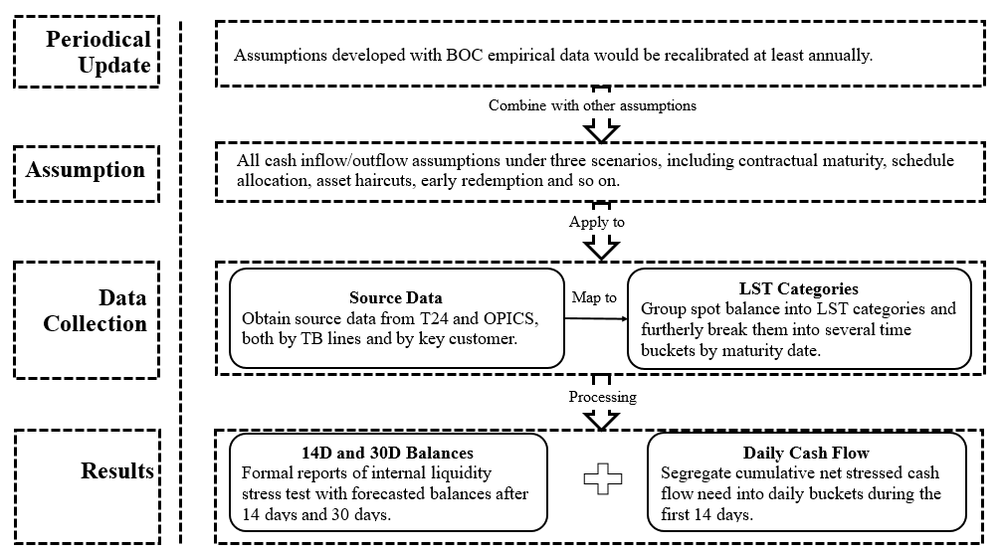
Figure 12: Implementation Process

Model Components
All assumptions and collected data are implemented into stress test model to get the final results, below table describes main sheets of each spreadsheet in the model.
Table 60: Stress test model workbook descriptions
Workbook | Tab | Descriptions
LST Template | Data Interface | This is the input from data collection file.
LST Template | RunoffChangeAdj | This tab is to update runoff rates of UFC, which are calculated in data collection file.
LST Template | Monthly Runoff Change | This tab is to update runoff rate of wholesale deposits provided in file “OD Multiplier Runoff”.
LST Template | FI Buckets | This tab is to calculate blended runoff rates of FI deposits.
LST Template | Assumptions | This tab contains all the assumptions that are developed for the three scenarios.
LST Template | Data Processing | This tab pulls all the data together (Balance, Maturity, Assumptions), and calculate the cash flows.
LST Template | Model Report Formalized | This is the formal results of stress test model containing balance after 14 days and 30 days under three scenarios.
LST Template | Daily Cash Flow | This tab segregates the cumulative net stressed cash flow need into daily buckets during the first 14 days, also bifurcates the internal and external cash flows.
LST Data Collection | Unfunded Credit Commitments | This tab retrieves data from T24 and calculate the weighted average drawdown rate.
LST Data Collection | ALL TB DATA | This tab maps all data extracted from T24 and OPICS to LST categories and break it down into several time buckets.
LST Data Collection | EXTRA INPUT | This tab is for manually inputting federal reserve requirement.
LST Data Collection | SUM BY LST CODE | This tab sums all data by LST categories, checks the balance between Assets and liabilities.
LST Data Collection | OUTPUT INTERFACE (LST) | This is the output interface in data collection file.
OD Multiplier Runoff | Multiplier | This tab calculates key customer multipliers based on their total deposit balance as a percent of liabilities.
OD Multiplier Runoff | LargeCustomerOP | This tab obtains operational deposit proportion from 3-month average debit, described as the net debit approach.
OD Multiplier Runoff | RunoffRatio | This tab calculates final blended runoff rate based on basic assumptions, multiplier and operational deposit proportion.

Implementation testing
Significant updates in methodology and assumption have to be tested within liquidity stress test model to ensure the change would provide accurate and reliable result before the new model is deployed into production. Please refer to below table for the implementation testing of assumption updates conducted in 2020.
Implementation testing is also required when there are updates with significant change in source data system, such as T24 or OPICS. TRY would conduct User Acceptance Testing (UAT) on test data extracted from the new version of data source system. If there are aspect of the new source data that does not meet the data need, TRY will work together with related departments to determine a solution.
Table 61: model change Implementation tests since 2020
Change Date | Change | Implementation Test | Changed by | Reviewed By
1/9/2020 | According to methodologies developed in MRA-4, updated FI deposits tier bounds and UFC drawdown rates of each segment, as renewal of 2020. | PASS | Shiyao Lu  Xiangjun Chen | Hongsheng Guo
2/27/2020 | Implemented TRY's proposal to change H.O. overnight funds run-off rates. | PASS | Xiangjun Chen | Hongsheng Guo
3/17/2020 | Incorporated the periodical regulation change: since 03/16/2020 FRB changes required reserve balance of all banks/deposit agencies to 0. | PASS | Xiangjun Chen | Hongsheng Guo
10/17/2020 | Added 90-day and 1-year run-off/drawdown assumptions for FI deposits and unfunded loan commitments. | PASS | Xiangjun Chen | Hongsheng Guo
1/25/2021 | According to methodologies developed in MRA-4, updated FI deposits tier bounds and UFC drawdown rates of each segment, as renewal of 2021. | PASS | Xiangjun Chen | Hongsheng Guo
1/29/2021 | Implemented TRY's proposal to change FDIC Sweep deposits run-off rates. | PASS | Xiangjun Chen | Hongsheng Guo

Model Operational Control

Overall operation control
Access Control
Access to Liquidity Stress Test model is limited to model users (designated members in Balance Sheet Management team) and reviewers in Treasury department, by protecting model templates with password. The password will be periodically updated and must not be shared with or made available to anyone in any manner that is beyond approved user list, unless for reviewing and auditing purpose required by MRD, ERM, and IAD.
Version Control
This document contains the following tables regarding version control:
Version History Table
Running list of all the version of the document since from inception, describing the change, the person who made the change, the date of the change, and the Version number
Document Information Table
Meta data relating to the document that identify name of the document, owner location, contact person, effective date and other relevant fields
Approval and Review Table
Table with information relating to the date and person conducting the review and approval.

Model Use Procedures
This section below describes the process and procedure to run the stress test model. Running the stress test model comprises the following four steps:
1. Collect the required data inputs
2. Run the stress test model
3. Generate the excess buffer results
4. Analyze the stress test results

Step 1: Collecting the required data inputs
The data collection step uses workbook “LST Data Collection”, which is designed to support automated refreshing of input data.
Select the tab “DATA INPUT”. Input the date we need at “B1”, e.g. “08/31/2017”.
Next, input the unpledged security market value, the amount would be sent by MKD at the first business day of each month.
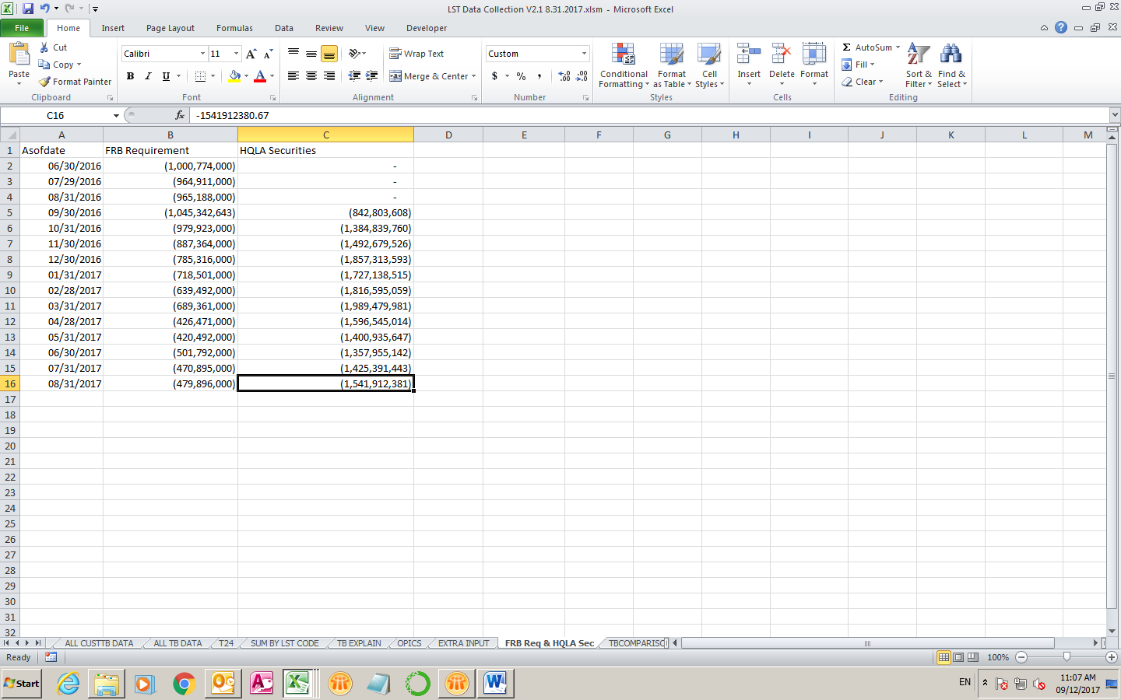
Finally, click “Get Data” and “Data Processing” in order, and everything else will be updated automatically, including retrieving data from T24 and OPICS, summarizing them by TB line and customer, as well as category of assumptions. The resulting tab is “OUTPUT INTERFACE”, which contains all data that test model needs. Just simply copy all of them into workbook “LST”, tab “Data Interface” using button “Copy to LST”, the two tabs have exactly the same format.

Step 2: Run the stress test model
Workbook: LST
As mentioned above, the assumptions for cash inflow and cash outflow are linked to the Assumption tab and the data for all the different balance sheet line items are from Data Interface tab. User shall choose the different scenarios at the top of the tab in order to see the different results. See the orange circle in the below snapshot.
Spreadsheet controls
Different types of controls have been set up in this workbook and the following components:
1. Assets = Liabilities + Equity
Both of the controls are set up at the last roll after Total Liabilities and Equities; user should make sure there is no discrepancies cross this roll in each tenor. This indicates both of the above conditions are met.
Data protection
2. The data in this workbook is protected by password against changing or deleting any data. Only authorized users are allowed to change any static data in this workbook.
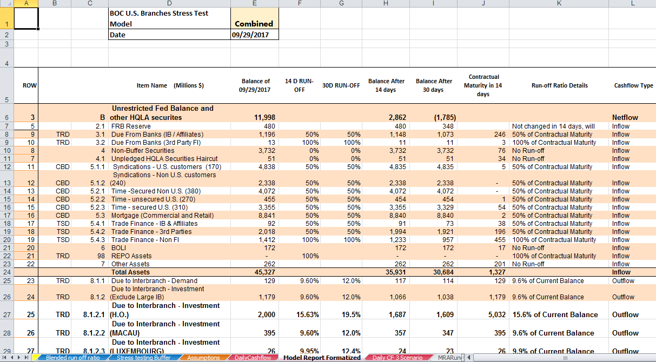
Please note, the blue coded data, and 9/29/2017, at the top of the tab, circled in blue, are the only places that the user can input. This is a consolidated version of the stress test model; underneath this balance sheet, there is a break down version which contains all the detailed GL (TB Line) items. Assumptions are developed based on the GL items.

Step 3: Update Security Haircut and Pledged Amount
Workbook: LST Tab: Para Adj
Input the sum discounted market value under 3 different scenarios, provided by MKD along with aforementioned unpledged security market value, into the tab.
Step 4: Generate the buffer results
Workbook: LST Tab: Daily CF 3 Scenarios
This tab provides the results of the stress test in three scenarios. This tab is linked to the Data Processing tab. Once a scenario is chosen, the results will automatically be displayed in this Buffer tab. Please see below snapshot for information.
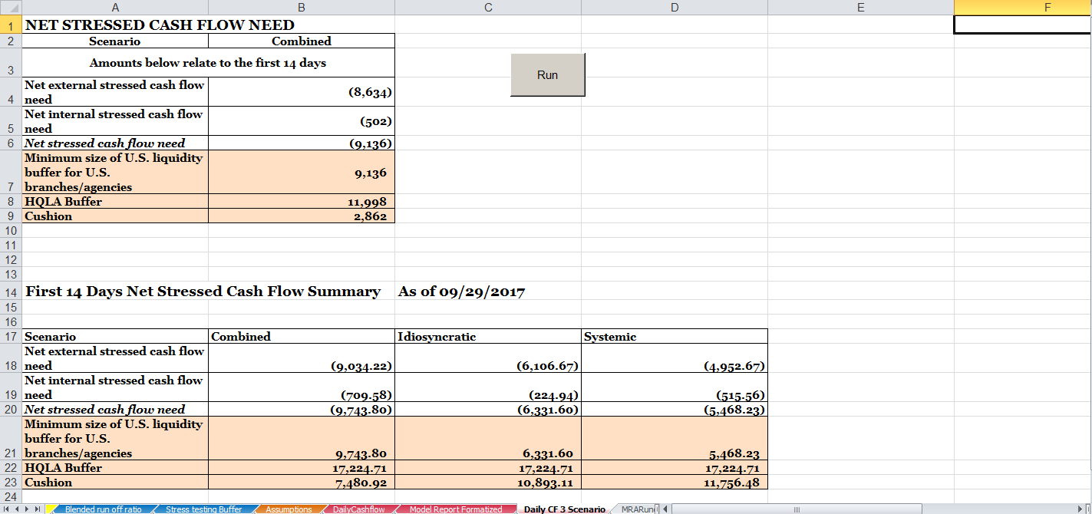
Spreadsheet controls:
The control on reconciliation:
The red circle above indicates the control put in place to make sure the buffer results generated here is equivalent to the numbers from LST workbook.
The Run button on the right of this tab is a built-in macro to record the buffer results in three different scenarios both in 14 days and 30 days. After user clicks the Run button, circled in orange in the above screenshot, the results will be shown in the same tab as the below screenshot.
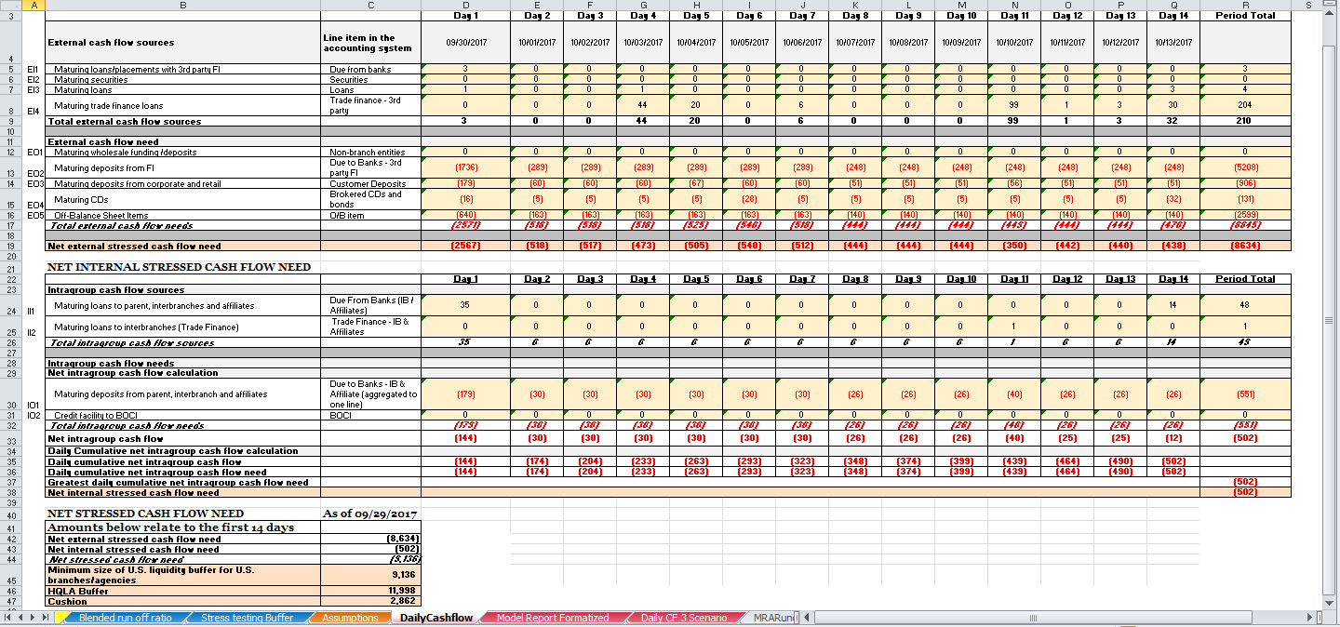
Step 5: Analyze the stress test results
The stress test results are analyzed and compared with previous periods. The results will be shown in the following formats to facilitate communications.
The below chart is an example of buffer result presentation. The yellow bar represents the buffer from starting point to 14 days, followed by the 30 day buffer results. The red bar represents the outflows from liabilities, the green bar represents the inflows from assets, and the grey bar represents the outflows from off-balance sheet items.
Liquidity Buffer Waterfall Chart – Combined Crisis

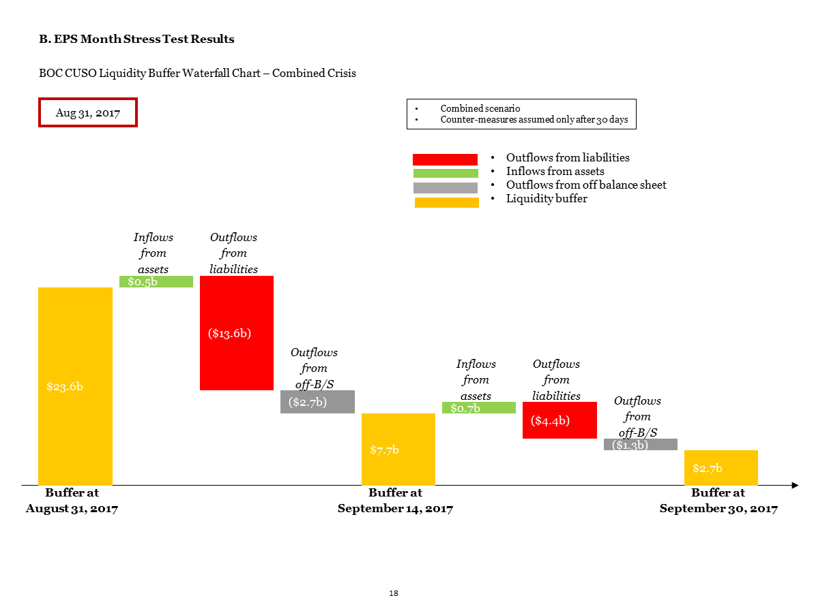Key steps to address common issues
Scenario 1 – New TB line
Workbook: LST Data Collection
- Add new TB code and explanation in TB EXPLAIN tab.
- Add new row in ALL TB DATA tab to map and aggregate new TB data from T24/OPICS tab by LST category and maturity.

Scenario 2 – New Key Client
Workbook: OD Multiplier Runoff
- Identify new key client in Multiplier tab and add new key client in LargeCustCluster tab with index.
- Add new row in LargeCustomerOP tab to aggregate new key client data from BalanceData and TransactionData tab and exclude new key client data in related client segmentation accordingly.

Workbook: LST Data Collection
- Add new row in ALL CUSTTB DATA tab to retrieve new key client data from T24/OPICS tab by TB code, customer number and aggregate by maturity.
- Add new row in ALL TB DATA tab to map new key client data from ALL CUSTTB DATA tab into LST category and exclude new key client balance in related TB line accordingly.
- Add new row in OUTPUT INTERFACE (LST) to summarize new key client data from ALL TB DATA tab.

Workbook: LST Model
- Add new row in Monthly Run-off Change tab to allocate new key client’ blended runoff rate, which based on operation ratio and multiplier analysis (Runoff schedule: D1-D14, 3W, 1M-12M). Note: If new key clients is FI type, a new row in FI Buckets tab need to be added to obtain new key client data from Data Interface tab first.
- Add new row in Blended Maker tab to map new key client’ operation ratio and blended runoff rate from Monthly Run-off Change tab.
- Add new row in Assumption tab to summarize new key client’s runoff schedule from Monthly Run-off Change tab.
- Add new row in Data Processing tab to pull new key client’s balance, maturity and assumptions from Data Interface and Assumption tab for stress testing calculations.
- Add new row in Model Report Formalized tab to finalize result with new key customer added.
Above process are the key steps to address these two common issues. Template formula could be auto filled down to perform calculations but additional adjustments and tests should to be considered.

Model Governance and Monitoring

Roles and Responsibilities
Treasury Department (TRY)
TRY is the model owner of Liquidity Stress Test and is ultimately accountable for model use and performance. It is responsible for
- Coordinating with all Model Risk Management (MRM) stakeholders and be responsible for the entire model life cycle
- Responsible for overall function relating to model assumption, model operation, risk measurement and risk reporting, including:
  - Developing model and stress testing assumptions
  - Collecting model input, calculating and updating assumptions
  - Generating Internal Liquidity Stress Test reports and ensuring accuracy of risk result
  - Conducting ad-hoc stress test, scenario analysis, and model back testing
- Submitting the model results in line with the requirements defined by BOCNY MRM procedure
- Coordinating with different MRM roles to remediate internal (e.g. Model Validation and Internal Audit) and external (e.g. Regulators) findings
- Monitoring model performance and report issues to MRM for model risk management

The following units help control the risk of model assumption & model use and provide independent review that challenge the existing model practice by conducting independent validation and review process:
Market Risk Management Department (MRD)
MRD, a model user and as the second line of defense, is responsible for:
- Conducting independent review on key assumptions in Liquidity Stress Test model specifically assumptions from market/liquidity risk management perspective.

Enterprise Risk Management-ERM
ERM’s responsibilities include
- Developing, implementing and maintaining the Model Risk Management framework for BOCNY, including model governance, policy and procedure
- Conducting model identification, model review and model validation

Internal Audit (IAD)
IAD, is the 3rd line of defense, it is responsible for:
- Verifying the consistency between MRM activities with MRM policy and regulatory requirements
- Verifying that MRM framework is well designed, effectively implemented and sustainably maintained

Ongoing Monitoring
As model characteristics and behaviors may evolve over time, to ensure the model still reflects the current reality that best estimate the risk, BOCNY conducts ongoing model monitoring periodically:
Runoff rates back testing
Update Frequency: Based on management needs
Conducted by: TRY
Threshold: Not Applicable
Assumptions Recalibration
Update Frequency: At least annually
Conducted by: TRY
Reviewed by: MRD
Threshold: Not Applicable
Additional Ad-hoc analysis are performed when needed.

Methodology Document Update
Following Policy on Policies & Procedures of ORD, the LST methodology document will be reviewed periodically for potential updates or approvals at least every three (3) years or more frequently to address potential trigger events.
Trigger events may include but not limited to new methodology or changes of existing methodology, new products, regulatory examination findings, audit findings, system or process changes, merger or divestiture or other major business event.

Appendices

Glossary
Abbreviation | Full Name
BOC CUSO | Bank of China Combined U.S. Operations
BOCNY | Bank of China New York Branch
TRY | BOC U.S. Branches Treasury
CBD | BOC U.S. Branches Corporate Banking Department
MKD | BOC U.S. Branches Global Market Department
MRD | BOC U.S. Branches Market Risk Department
ERM | BOC U.S. Branches Enterprise Risk Management
IAD | BOC U.S. Branches Internal Audit Department

Additional Analysis

Federal Reserve Balance
BOCNY generally parks excess cash in its Federal Reserve Bank account. The balances have been volatile given the nature of its liability portfolio.
Federal Reserve Bank balance of BOC U.S. Branches is very volatile from 2010 to 2018. The lowest balance was $0.8 billion in July 2010 and the highest balance was $79 billion in September 2015. Thus, it is critical for TRY to closely and frequently monitor the buffer balance to ensure proper control is in place.

Deposits from Corporate Customers
To further understand the product mix and characteristic of corporate customers, we did additional analysis on four types of deposits from corporate customer’s profiles. Below table provides the information of the TB line and the corresponding name of the four deposits. The four types of corporate deposits represent the data from balance sheet line item Corporate Deposits, as shown in Table 62: Corporate Deposits Items and Trial Balance Lines.
Table 62: Corporate Deposits Items and Trial Balance Lines
TB Line | Description
4131 | DEMAND DEPOSITS-NON PERSONAL
4154 | DEMAND DEPOSIT-INT CHECKING
4200 | MONEY MARKETS-NON PERSONAL
4208 | CORPORATE MONEY MARKET FUNDS
For each type of the above four corporate deposits, we extracted the daily balance of each customer, and broke the customers into five quantiles. (For more information about the quantiles, please refer to below quantile description). Then we put into analysis to see the distribution of these quantiles to understand the nature of these deposits.
The conclusion can be inferred from the analysis is, significant volatility was statistically related to highly concentrated deposit (few customers counts for large portion of total deposit), with weight of daily balance into consideration.

Cash Flow Projection Research & Study References

Reference I
A research paper titled “Old-Fashioned Deposit Runs” by Jonathan D Rose exhibited deposit outflows at large institutions during the financial crisis.
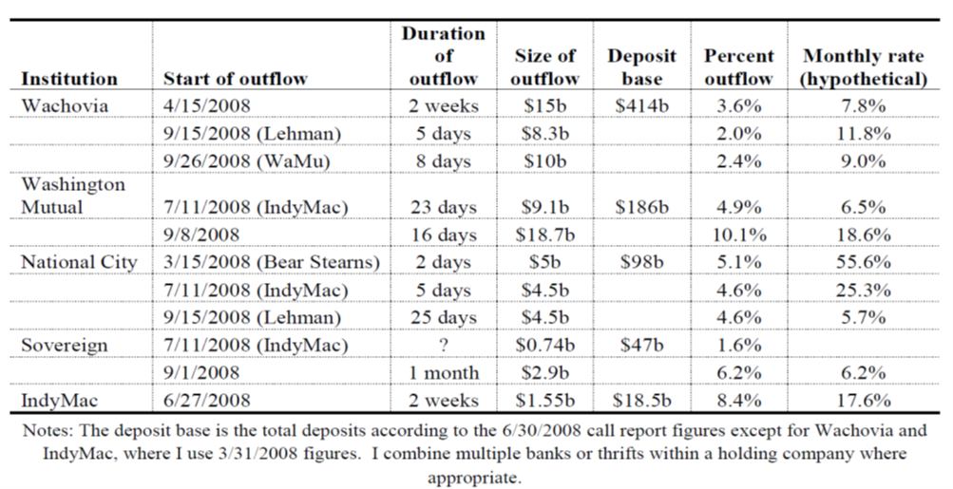
Figure 13: Deposit Outflows at Large Institutions during the Financial Crisis

Reference II
Industry study provided by KPMG shows the quarterly outflows for failed banks during the 2008-2009 Financial Crisis.
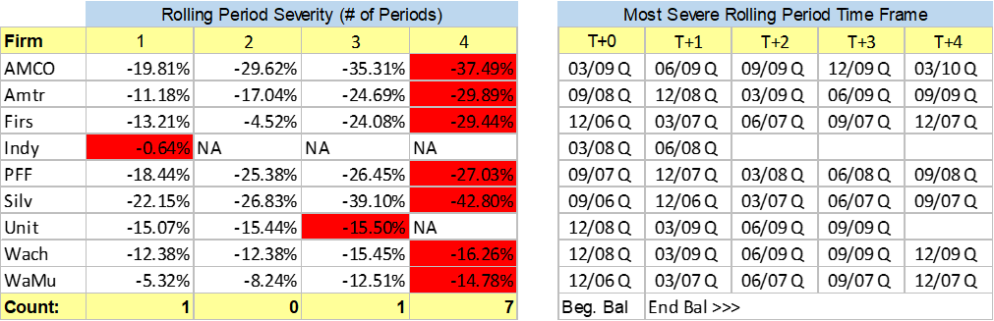
Figure 14: Most Severe Rolling Period Outflows for the Failed Banks
As aforementioned, there is not any industry or research paper assessable that is granular enough to derive the daily run-offs. After discussing with external consulting firms, the Bank confirmed that most peer banks face similar issues when estimating the daily cash flow projection for liquidity stress testing. One widely used approach is a linear method for daily run-off projection, while some large banks may use sophisticated approaches that based on their own historical data or expert judgements. Given the Banks’ business and product portfolio, complex models are not necessary for BOC.

CUSO Risk and Finance Officers
Name | Title | Email | Office Phone
Mr. David Farrell | CRO, BOCA | david.farrell@bocaviation.com | +65 63259508  M: +65 9299 6360
Mr. Kenneth Ng | Deputy Head, Risk Management, BOCA | kenneth.ng@bocaviation.com
Ms. Felicia Ng | Head of Accounting Department, BOCA | Felicia.Ng@bocaviation.com | +65 6325 9518  M:+65 9727 1160
Ms. Sabeena Ahmed | General Counsel/Head of Risk Management Unit for all BOCI US entities | Sabeena.Ahmed@bocigroup.com | 212 554 8811
Ms. Grace Zhou | Executive Director and Front Office Business Manager, BOCI CFUS | grace.zhou@bocigroup.com | 212 554 8810
Mr. Kyle Lo | Head of Finance and Treasury, BOCI USA | KyleKL.Lo@bocigroup.com | 212 554-8808
Ms. Carman Zhou | Chief Operating Officer, BOCI USA | Carmen.Zhou@bocigroup.com | 212 259 0890

Reference

Treasury (Aug 2019), Contingency Funding Plan – BOC Combined U.S. Operations

Federal Reserve Bank (Jan 2020), Enhanced Prudential Standards (Regulation YY), www.govinfo.gov/app/details/CFR-2020-title12-vol4/CFR-2020-title12-vol4-sec252-145/context

Federal Reserve Bank (Jan 2015), Enhanced Prudential Standards (Regulation YY), www.govinfo.gov/app/details/CFR-2015-title12-vol4/CFR-2015-title12-vol4-sec252-157/context

Financial Management Department (2019), Operational Deposit Methodology Document

Financial Management Department (2019), Liquidity Stress Testing – Wholesale Deposit Run-off Assumptions

Treasury (Oct 2019), EPS LST MRA Remediation Resolution – Financial Institution Run-off and Unfunded Loan Commitment Drawdown Assumptions

Bank of China (Dec, 2019), Bank of China Credit Rating History www.boc.cn/en/investor/ir4/201311/t20131114_2637906.html

The Clearing House (Nov, 2011), The Clearing House: Assessing The Liquidity Coverage Ratio

Bank for International Settlements (Jan, 2013), Basel III: The Liquidity Coverage Ratio and Liquidity Risk Monitoring Tools

Federal Reserve Bank (Oct 25, 2018), Policy Tools: Regulatory Changes in Reserve Requirements and Indexation of the Low Reserve Tranche and the Reserve Requirement Exemption, 83, https://www.federalreserve.gov/monetarypolicy/reservereq.htm

Global Market Department (Oct, 2017), EPS LST MRA #2 Remediation Resolution - Asset Haircuts Proposal

Financial Management Department (Aug 2017), EPS LST MRA #1 Remediation Resolution – Daily Cash Flow Projection

Financial Management Department (Aug 2017), EPS LST MRA #2 Remediation Resolution – Commercial Paper Direct Pay and 80/20 Run-off Rates

Financial Management Department (Aug 2017), EPS LST MRA #3 Remediation Resolution – Early Redemption Rate for Directly Issued Time Deposits

Federal Reserve Bank of New York (May 2019), 2019 Horizontal Liquidity Review (HLR)

BOC Head Office (2019), BOCNY Business Authorization

Enterprise Risk Management Department (Aug 2020), Bank of China US Branches Risk Governance Framework

Basel III: The Liquidity Coverage Ratio and Liquidity Risk Monitoring Tools – Paragraph 154
Basel III: The Liquidity Coverage Ratio and Liquidity Risk Monitoring Tools – Paragraph 153 & 154
Basel III: The Liquidity Coverage Ratio and Liquidity Risk Monitoring Tools – Paragraph 145
Basel III: The Liquidity Coverage Ratio and Liquidity Risk Monitoring Tools – Paragraph 106
The Clearing House: Assessing the Liquidity Coverage Ratio – Page 16 “Retail Deposit Run-off”
In the original LST methodology, the overnight run-off rate of retail demand, MM, and savings deposits is 2% for combined scenario, aligns with the underlying assumptions that 20% of the 30-day deposit run-off occur on the overnight horizon; however, after MRA #1 remediation resolution was implemented, the run-off schedule within 14 days has changed and the overnight run-off for customers other than interbranches, affiliates, or third party FIs becomes 20% of the total runoff on 14-day horizon [12]. Similar changes were also made to idiosyncratic and systemic scenario assumptions.
Basel III: The Liquidity Coverage Ratio and Liquidity Risk Monitoring Tools – Paragraph 79
The Clearing House: Assessing the Liquidity Coverage Ratio – Page 18. “Wholesale Deposit Run-off”
Basel III: The Liquidity Coverage Ratio and Liquidity Risk Monitoring Tools – Paragraph 107
Basel III: The Liquidity Coverage Ratio and Liquidity Risk Monitoring Tools – Paragraph 113 & 114
100% outflow rate was also employed under idiosyncratic and systemic scenarios within the 14-day and 30-day horizons to fit conservative purpose.
The drawn components has been captured as a 100% outflow within the 14-day and 30-day horizons under combined scenario based on supervisory feedback.
The Standard Portfolio Analysis of Risk (SPAN) system is a sophisticated methodology that calculates performance bond requirements by analyzing the "what-ifs" of virtually any market scenario.
BOCI CFUS confirmed the $150 million credit line adequate as of November 2019.

